**ACM Word Template for SIG Site**

**ABSTRACT**

In this paper, we describe the formatting guidelines for ACM SIG Proceedings.

**Categories and Subject Descriptors**

D.3.3 [**Programming Languages**]: Language Constructs and Features – *abstract data types, polymorphism, control structures.* This is just an example, please use the correct category and subject descriptors for your submission*.*

**General Terms**

Your general terms must be any of the following 16 designated terms: Algorithms, Management, Measurement, Documentation, Performance, Design, Economics, Reliability, Experimentation, Security, Human Factors, Standardization, Languages, Theory, Legal Aspects, Verification.

**Keywords**

Keywords are your own designated keywords.

**1. INTRODUCTION**

In recent years there has been many new non-contact human-computer interaction technologies, most of which are based on computer vision. But most of the gesture-based interactive methods of computer vision are sensitive to light, it requires higher computational complexity and more system, so the computer visual non-contact gesture interaction technology is not applicable to future wearable technology.

Taking into account the above factors，more and more experts have begun to study the use of ultrasound for gesture recognition. Considering the miniaturization of wearable equipment, limited performance and power, this research presents an opportunity for ultrasonic low-power hand gesture recognition method. The ultrasonic wave gesture recognition comes with the microphone and speakers which emit ultrasonic wave to recollect later. It extracts and analyzes the characteristics of the frequency variation of the acoustic signal caused by the change of the user's gesture, and then identifies the user's gesture.

Human–Computer Interaction (HCI) based on gesture recognition become more and more important, especially for smart mobile devices. Voice, electromyography sensors and brainwave sensors, in-air gesture recognition have more special advantages than HCI based on touch screen in several scenarios, especially in recent years in-air gesture recognition has been improved. It is easy to learn and does not have to contact with the device. The new way based on ultrasonic can perform low computational gesture recognition which does not have to use special equipment, and light or noise will not disturb the gesture. This new approach offers a easier and faster way to operate the device.

In conclusion, we present ultrasonic wave which is a sound-based gesture sensing approach, using the existing audio hardware of mobile devices. This technique uses “Doppler shift” or “Doppler effect”, which identify the sound wave change as a listener closes to or keep away from the sound. A common example is the change in pitch of a vehicle siren as it closes, passes, and then keeps away from the listener. By using this effect, ultrasonic wave could detect the changes around or in front of a computing device, such as the direction, speed and so on. For example, we use as a “rotation” gesture to detect two hands moving in opposite directions in our example applications which is different from vision, ultrasonic wave can detect gestures without line of sight.

**2. TECHNICAL BACKGROUND**

We are not the first to use ultrasonic-based gestures controls in Human Computer Interaction. In recent years, there have been many fantastic and novel non-contact human-computer interaction technologies, most of which are based on computer vision. For example, Kinect is used to reduce the 3D model by sensing the black and white spectrum to perceive user behavior. Relevant gesture recognition work is carried out, while the color map and depth map is captured through RGB-Depth Camera Capture. But the method based on the computer detect and gesture control is relatively sensitive to lightening condition. At the same time, the implementation algorithm is much more complex, which requires more system resources. On the contrary, wearable electronic equipment, whose power are really limited and not equipped with high level professional cameras. So, it may not be a proper way, and the computer-vision based non-contact gestures interactive technology is not suitable for most wearable equipment.

Ultrasonic-based gesture recognition technology, compared with non-contact gesture-based interactive technology which use computer vision, is attracting growing interest of researchers in companies and universities. And the use of ultrasonic human computer interaction has a long history. As early as 1997, Joseph Paradiso et al. [0] invented a new immersion carpet, which percepts the user behavior with the radar sound. This new carpet combined with other sensors in the carpet perceive and translate the user’s various actions and change it to music in real time. Moreover, Junjue Wang et al. [5] proposed a new approach for mobile devices to in put through conventional surfaces with fine-grained localization. Localization of keystrokes is measured by the amplitude spectrum density (ASD) of the click sound which is receipted by the microphone on the cellphone, achieving an accuracy of 95 percent. On the other hand, ultrasonic gesture is also used in image processing area, and it is proved to be extraordinarily useful by Richard J. Przybyla et al. [6]. In their research, an ultrasonic 3D gesture recognize system is presented using a custom transducer chip and an ASIC.

Applications controls are developed based on ultrasonic-based gestures. Many researches have been made on this topic. For example, Tarzia et al. [4] use the microphone on a laptop to measure the intensity of echoes produced by human presence (As shown in Fig 0). Sidhant Gupta et al. [14] concentrate more on the software solutions of ultrasonic-based gestures control, which utilizes speaker and microphone on a personal computer to recognize and detect hand movements, with the use of Fast Fourier Transform algorithm to process the acoustic signal and determine the user’s gestures. This research utilizes Doppler shifts of an inaudible tone at a high frequency of nearly 18kHz and 22kHz. The frequency shifts which happen at this moment were grabbed for two handed gestures as well as more complex gestures like clicking the mouse, double tapping or tapping a key in a short time for many times. Accuracy, however, need to be assured in this process. According to Chunyi Peng et al. [2] high accuracy is usually achieved by measuring time-of-arrival (TOA), which could be interfered by clock skew and drifts between devices, possible misalignment and delay of sound arrival. A pure software-based solution, Beep-Beep ranging mechanism is proposed to overcome all the uncertainties. Specified devices are introduced to recognize gestures based on Doppler effect. An even higher accuracy of prediction at 99.6 percent in ultrasonic gesture recognition is achieved by Kun Jin et al. [7], applying an Artificial Neural Networks (ANNs) method for classification (As shown in Fig X and Fig Y). Kalgaonkar et al. [3] built a low-cost device using Acoustic Doppler Sonar (ADS) with ultrasonic transmitter and three receivers (As shown in Fig 1). By composing signal changes in the multiple location of different areas to create 3D environment to determine user’s gestures, achieving an accuracy of 88.42 percent. This model involves a 40-kHz ultrasonic wave, and the sample frequency is up to 96kHz, ordinary speakers are not suitable for the requirement, while the use of multiple acoustic receivers are not equipped in smaller and versatile wearable equipment. Considering the complexity of the devices and platform, there is limitation adopting this method in a mobile context. Research and application attempts at designing a device like a SoundSense [11], in which four ultrasonic rangefinders are assigned in different edges of the device to find and translate hand gestures. Travis Deyle et al. [12] presents FingerMic, which is a trainable wearable device. This device could detect finger gestures, include for example, like the movement of thumbs, certain hand gesture, or certain gestures corresponding to the shape. Yang Qifan et al. [1] developed a gesture recognition application on Android devices using the loudspeaker and microphone embedded on the cellphone (As shown in Fig 2). They adopt a machine learning approach, and utilized the Doppler shift of ultrasonic reflected by human body moving, achieving a high classification accuracy of 94 percent over a set of 24 pre-defined gestures. However, this application is still in the stage of experimental and has not been widely adopted.

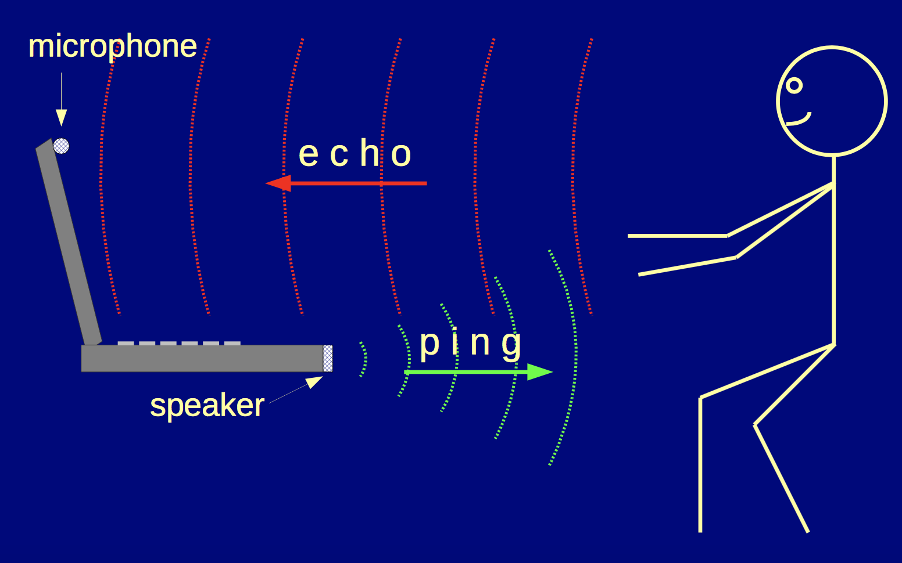

Fig 0. Tarzia’s prototype. Using the microphone on the laptop to detect human attention and presence.

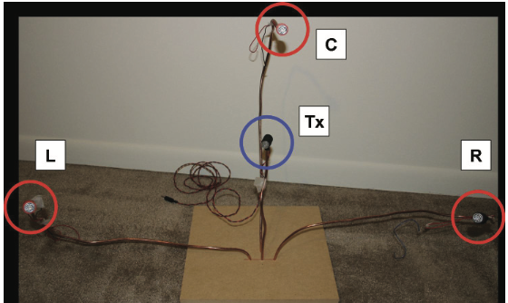

Fig 1. Kaustubh Kalgaonkar’s prototype device. Transmitter in the center and receivers in triangle pattern.

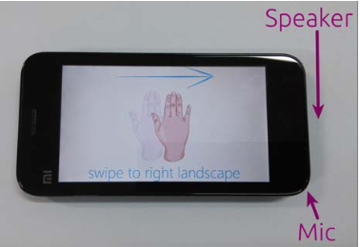

Fig 2. Gesture recognition based on ultrasonic capture on Android mobile device

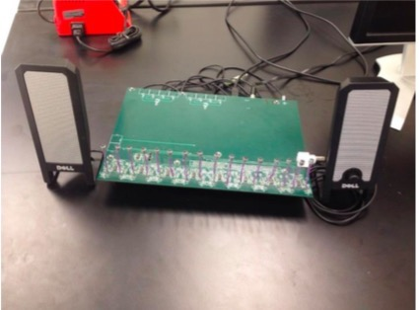

Fig X. Kun’s prototype of ultrasonic gesture recognition model

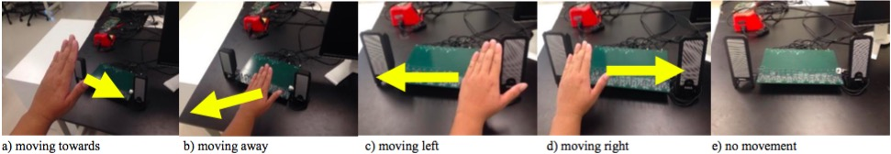





Fig Y. Experiments about recognizing different gestures

**3. DESIGN**

**3.1 Persona**

1. K.P. Steve is 35 year old. And he works in the bank as a commercial manager, he is busy with his work every day. He is in charge of many things such as hosting meeting, guiding the staff and writing reports. Steve really wants to improve work efficiency and high quality finishes work. Next morning Steve will have a meeting with a customer, he wants to show the concept of conference efficiently with high-tech and makes the meeting more vivid.

2. Lily is a 20 years old student at Faculty of Art in The University of New York. She really likes travelling and taking pictures especially taking selfie. Lily is an outgoing girl, she has travelled to many countries. In the summer holiday, Lily travels to Tokyo herself and really enjoys the beautiful landscape, taking a lot of pictures. As she travels by herself and can not take photos with scenery. Her goal is to take pictures with different kinds of landscape.

3. Michael is a 21-year-old college student, majored in Computer Science in HKU. He is kind of nerdy and enjoys video games very much. Owning many infrastructures like Xbox one, PlayStation 4, PC, he has a keen interest in games like Civilization, Skyrim, WOW, Halo and so on. However, most operations are accomplished via joysticks or keyboards, which bugs him a lot. He prefers a more interactive way to manipulate his avatar in a direct way. For example, he may attack an enemy demon with the magic power owned by the avatar by posing some gestures, acting like he is really attacking the demon other than playing with the joystick. Even though there are some technologies like Kinect, they still require good lightening condition, no mention their high prices and energy consumptions. Michael is dying for a more effective way of interaction with relatively reasonable cost and acceptable performance.

4. Tom is a manager of a financial company. He is young and energetic, while the busy daily work really makes him feel tired and stressful. Today he wants to drive to work. Usually when he is driving, he needs to enjoy music. He needs to press a lot of the buttons in order to play music. It is some kind of unsafe since he may not concentrate to driving. Also there always are some important friends who call him when he is driving. So he needs to click the button to answer the phone. He is really tired of the old fashioned interactive ways. He wants new ways to interact with these devices. It should be interesting, creative and also should be safe.

5. Stephen is a researcher in the national aeronautics and national administration. His research interest is to reduce the heavy work of astronauts. Astronauts are always floating in the space capsule because of the zero gravity. Usually the electronic devices and the food they need to eat is floating inside the space capsule. It could be quite uneasy to move in this such tiny space. They need to save their energy. So Stephen wants a new way to control some electronic equipment in the capsule so that the astronauts could use it without moving.

6.Tom, a 70 years old cardiac patient, he need family members’ help when emergency happens to take medicine for symptom alleviation. However, when the emergency come and no family members nearby, Tom will be dangerous because he will lose control and can not notify others instantly for help. Tom need a intelligent device to detect that emergency and tell other family members to come in time.

7. Jack is a software developer, who fancy new technology and something creative. He like purchase electronic products but he is not satisfied by the current interaction on touch screen. He desire a new natural non-contact interaction method to interact with day-time mobile devices so that he can operate the devices like smart phone naturally with natural gesture and movement instead of scratching on the screen or clicking.

**3.2 Task**

1. When Steve shows the meeting with the ppt, he can use different gestures to help him to turn page and change the size of words. He swipes up his hand to go to the before page and swipes down his hand to turn the page. And handing out of the screen to enlarge the font and handing to the inside of the screen to wipe the font.

2. When Lily wants to take photos, she could find a place to put her phone and choose the gesture model. After she has posed，she just waves her hands toward to the phone. Within 5 seconds, the picture will be taken.

3. A flexible way of interacting with gaming instruments is highly demanded. To fulfill the gap between traditional manipulating methods and these costly complex new interactions like Kinect, trade-off between consumption and performance must be considered. Otherwise, consider the tense atmosphere some games are trying to create, the lightening condition is always poor, which arise a major requirement of light-tolerance. With the help of soundwave reorganization of gestures, Michael will find a more comfortable and costless way to play video games even in poor lightening conditions.

4. A new way to ease Tom’s trouble is we could implement the ultrasonic wave gesture interact with the device. For example, Tom could put his hands near the MP3 player to open the MP3 player. He could shake his hands to select the music. When he wants to play the music, he could put his hands on the top of the screen for a while, the music will be played. When there is a phone call, he could just wave his hands near his mobile, and the phone would detect that and the call would be connected.

5. A new way which could help to solve Stephen’s trouble is to use this ultrasonic wave gesture control system. He could add this system to the tiny space capsule. It won’t take too much space and could be very easy to learn to use. When the astronaut wants to control some thing inside the space capsule. He doesn’t need to move his body and jump forward. It could be as easy as shake his hands and then the remote device would be controlled.

6. When a cardiac patient’s emergency happens, the ultrasonic wave device will detect it and alert family members to come in time.

7. Jack could operate the devices like phone or pad by pose designed gestures based on ultrasonic wave gesture recognition technology. For example, he can switch windows by move his hand horizontally, scroll a table list by translate his hand vertically or select the target element by move close to the device quickly.

**3.3 Function**

Today, the wearable or mobile devices are becoming smaller and smaller and also more power-limited as well. Some traditional human-machine interaction methods like screen touch or gesture recognition based on video can not satisfy that trend and demand, because the screen display is very power-consuming and the device for gesture recognition based on video is too big to be inserted into our mobile devices conveniently. In the near future, it will be inevitable to apply a new natural interaction method as a replace of that current traditional interaction ways.

**3.4 User Interaction Design**

The gesture recognition based on ultrasonic wave is mainly based on Doppler effect and the fact that hand movement could change the wave frequency. The advantages of that is it’s low-power demanding and not mobile device demanding. Take the application on smart phone as an example: we can easily use the phone's speaker to emit voice waves including ultrasonic wave, and then retrieve the wave with the phone's micro-phone. If the user's hand make movements within the valid area, then the frequency of the wave will be changed which means the movement information has been record in it. Besides the wave frequency range that the speaker can generate is 18kHz~22kHz, and human ears' perception frequency range is 20Hz~20kHz, so letting the device emit voice wave of 22kHz will not influent people's life or other bad effects. After retrieve the wave data, then some algorithms will be used to extract and analyze the movement feature so that we can get the move direction information. Then the move direction information will be used as the input of HHM(Hidden Markov Model) to get the final gesture recognition result. In addition, in the phase of the final gesture recognition, a machine learning model will be trained to judge the gesture intelligently.

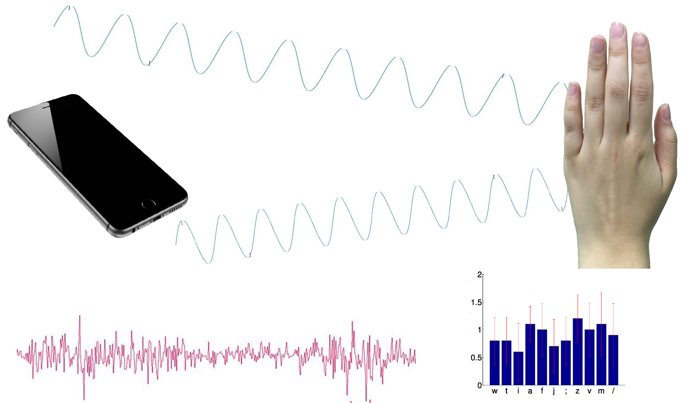

**3.5 Gestural Control**

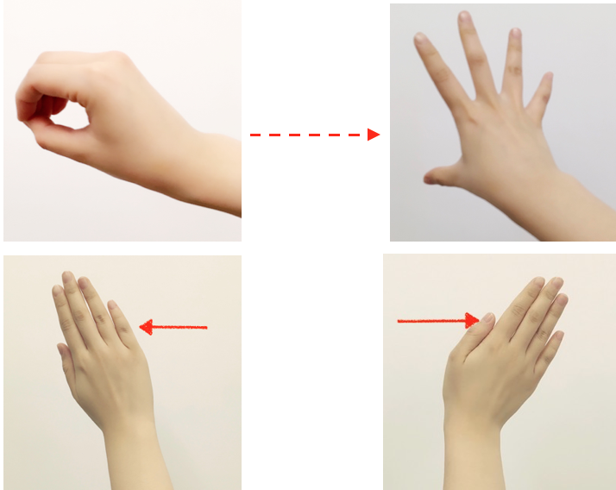

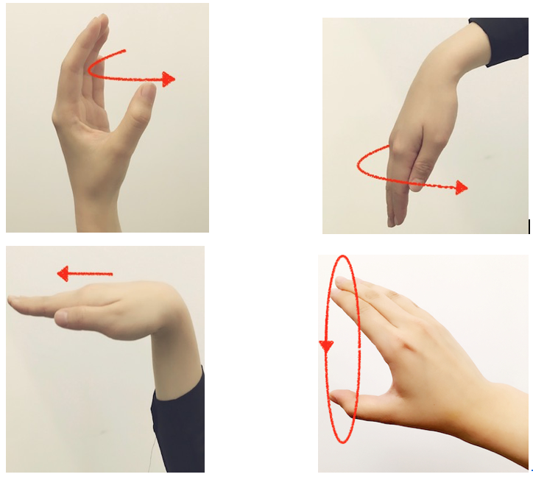

B:back

SB:second back

F: front

SF:second front

N: none

Close:

F---->N

Away:

B---->N

Click：

F---->B---->N

Double click:

F---->B---->SF---->SB---->N

**3.6 Icon Design**

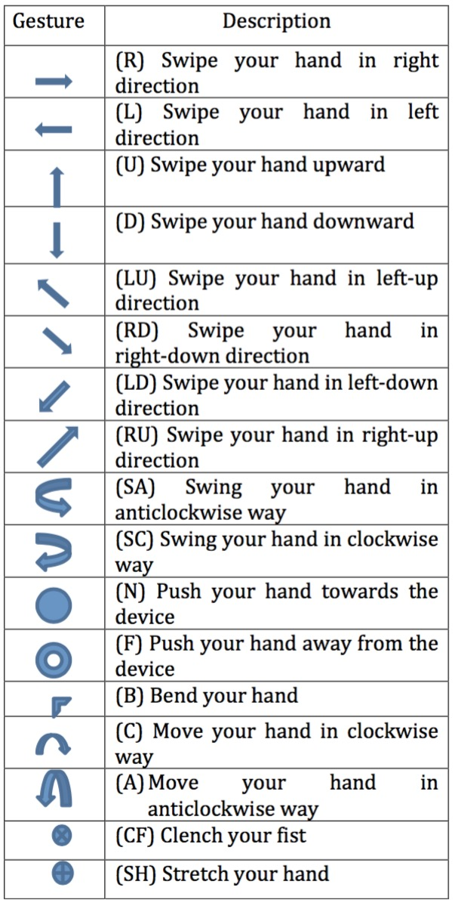

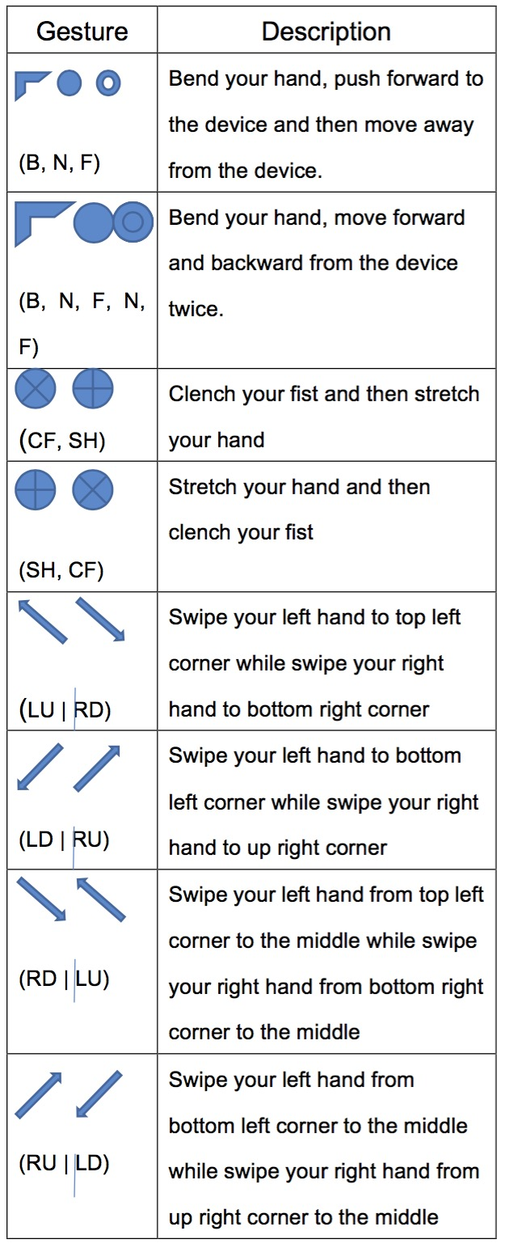

**4. PROTOTYPE IN STORYBOARD**

Because we have finished all the storyboard digital drawing in our prototype, we will use our complete prototype to illustrate the storyboard at the same time. Meanwhile, due to this document format is relative narrow, our prototype diagram is resize into a small size. We have uploaded another document that includes all the diagram in a large size for view and a prototype video. The link for download is below:

**4.1 Scenario 1 Meeting presentation**

The action list of task 1 is

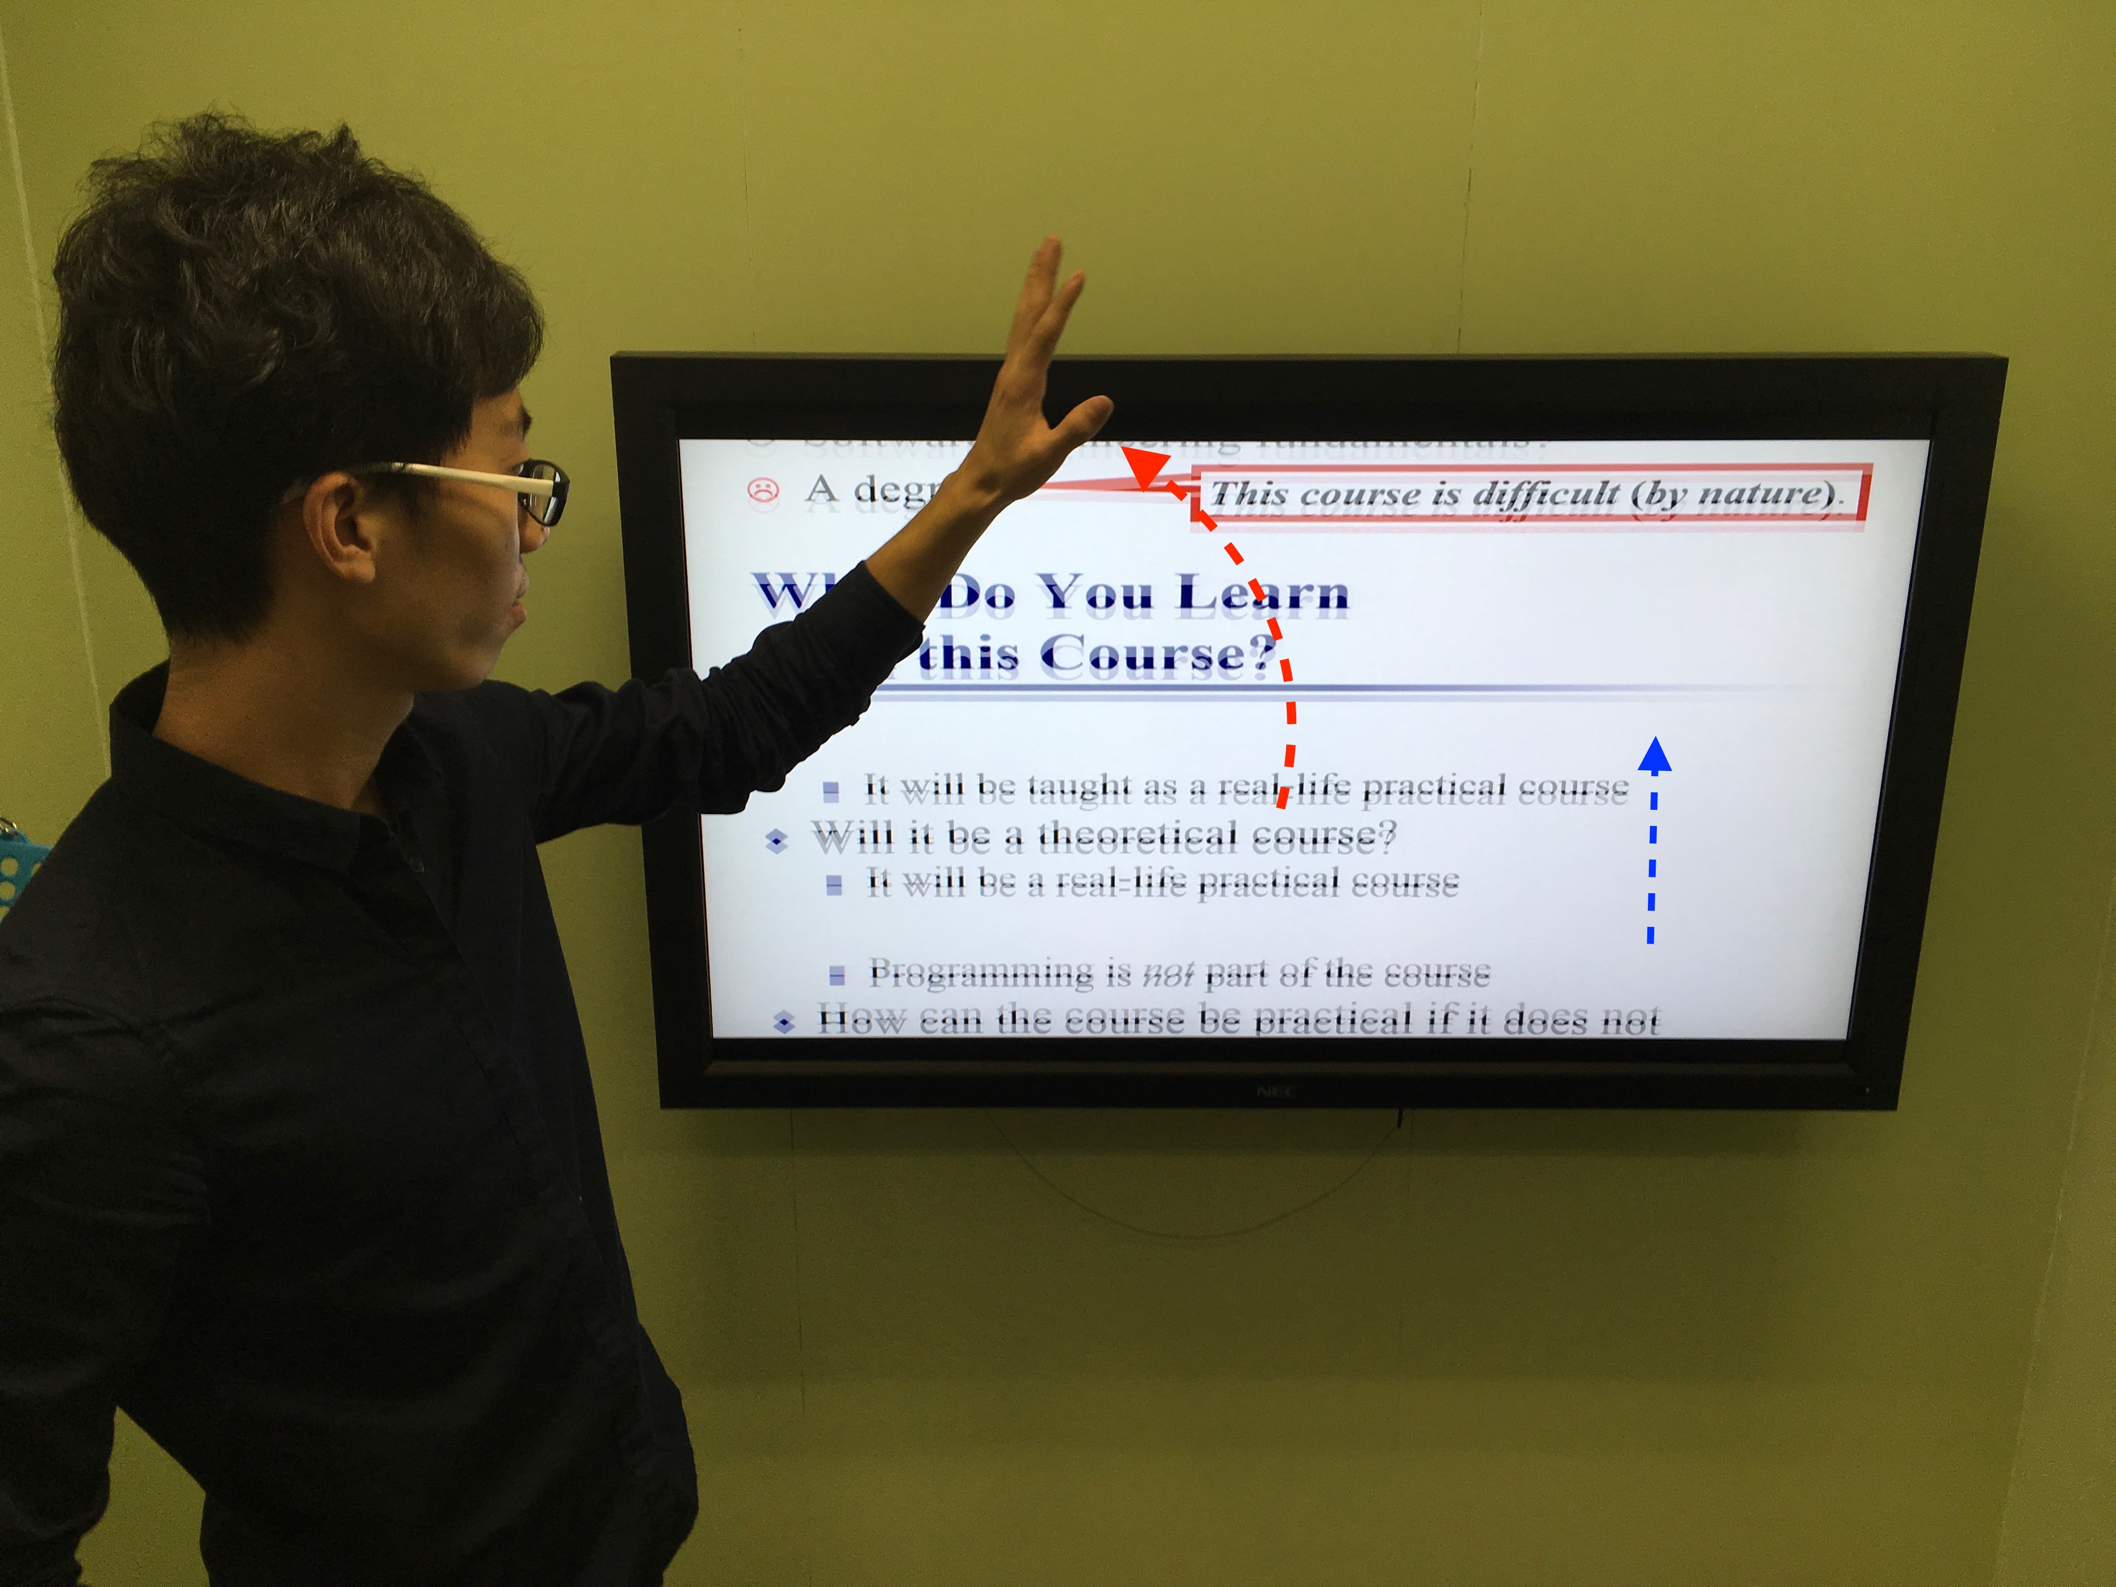

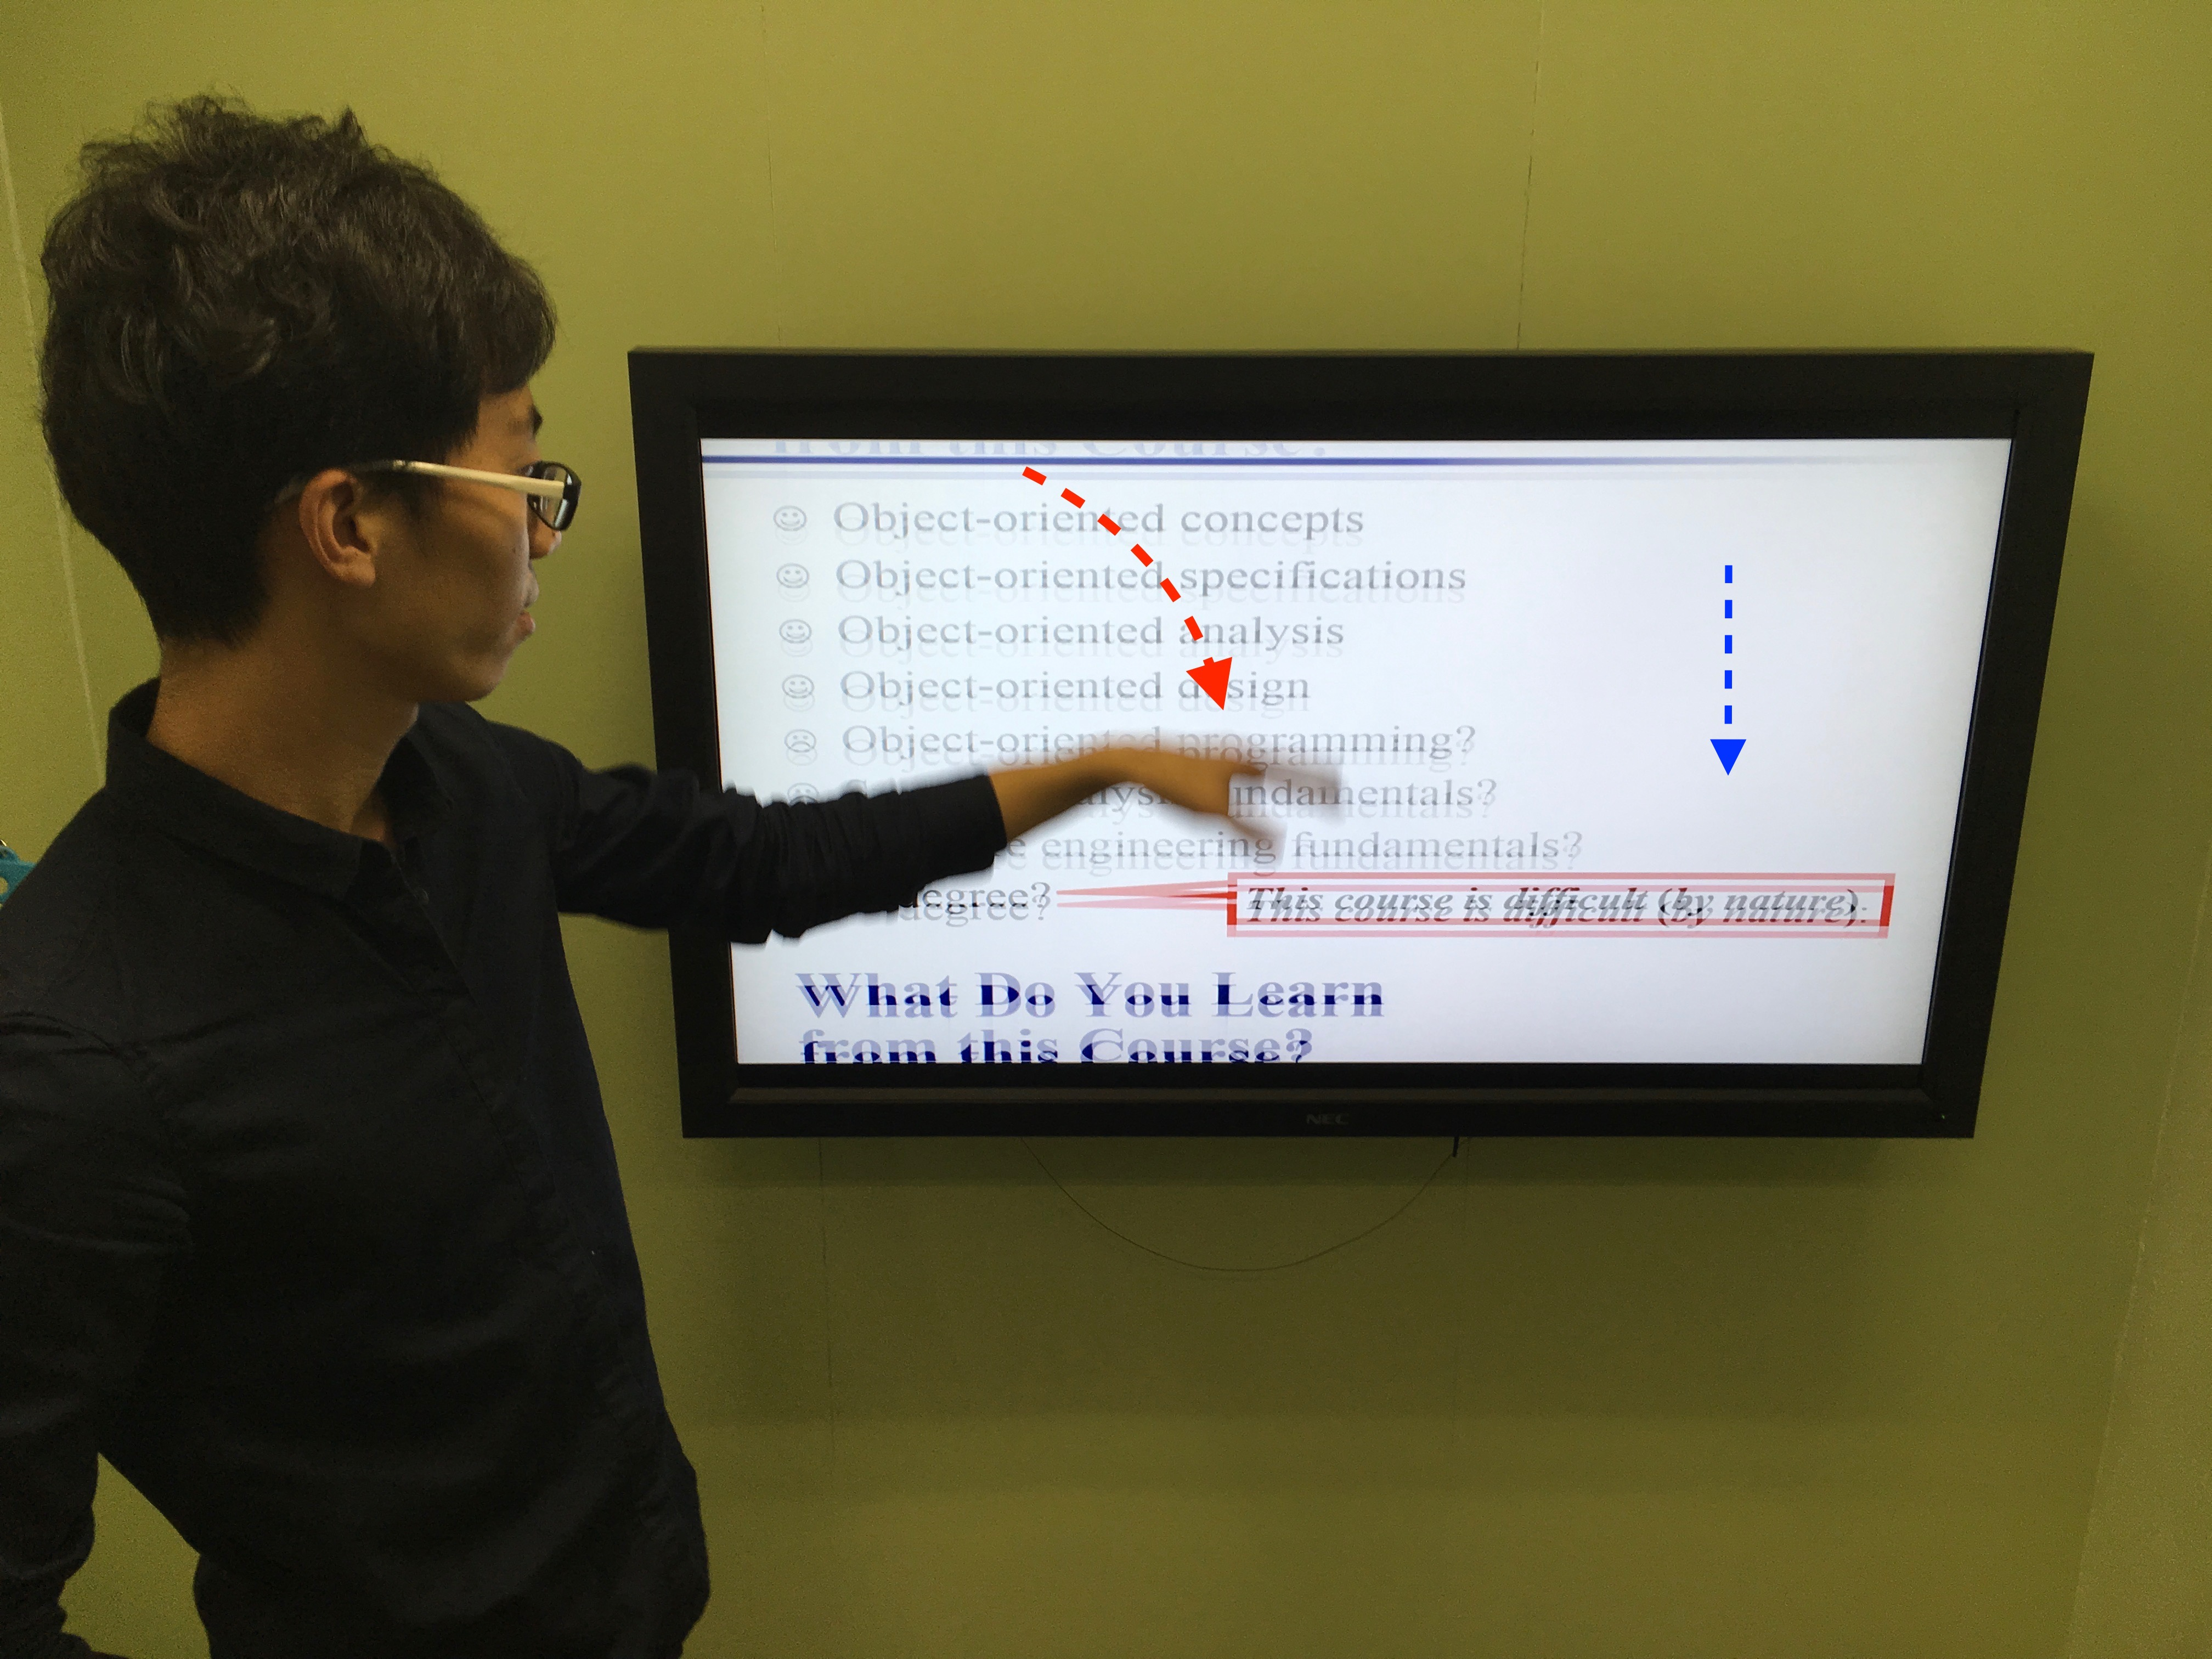

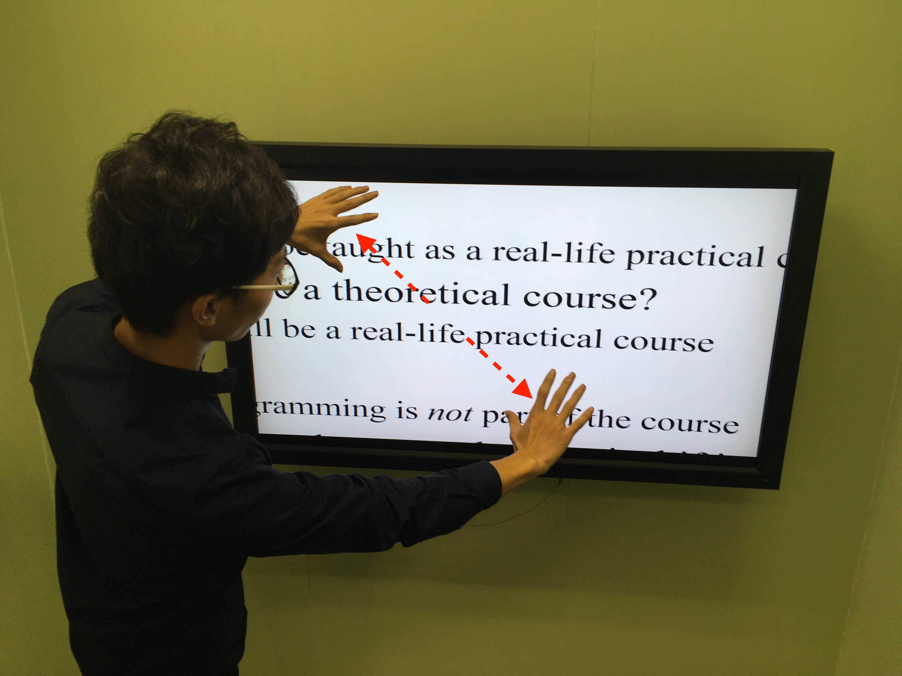

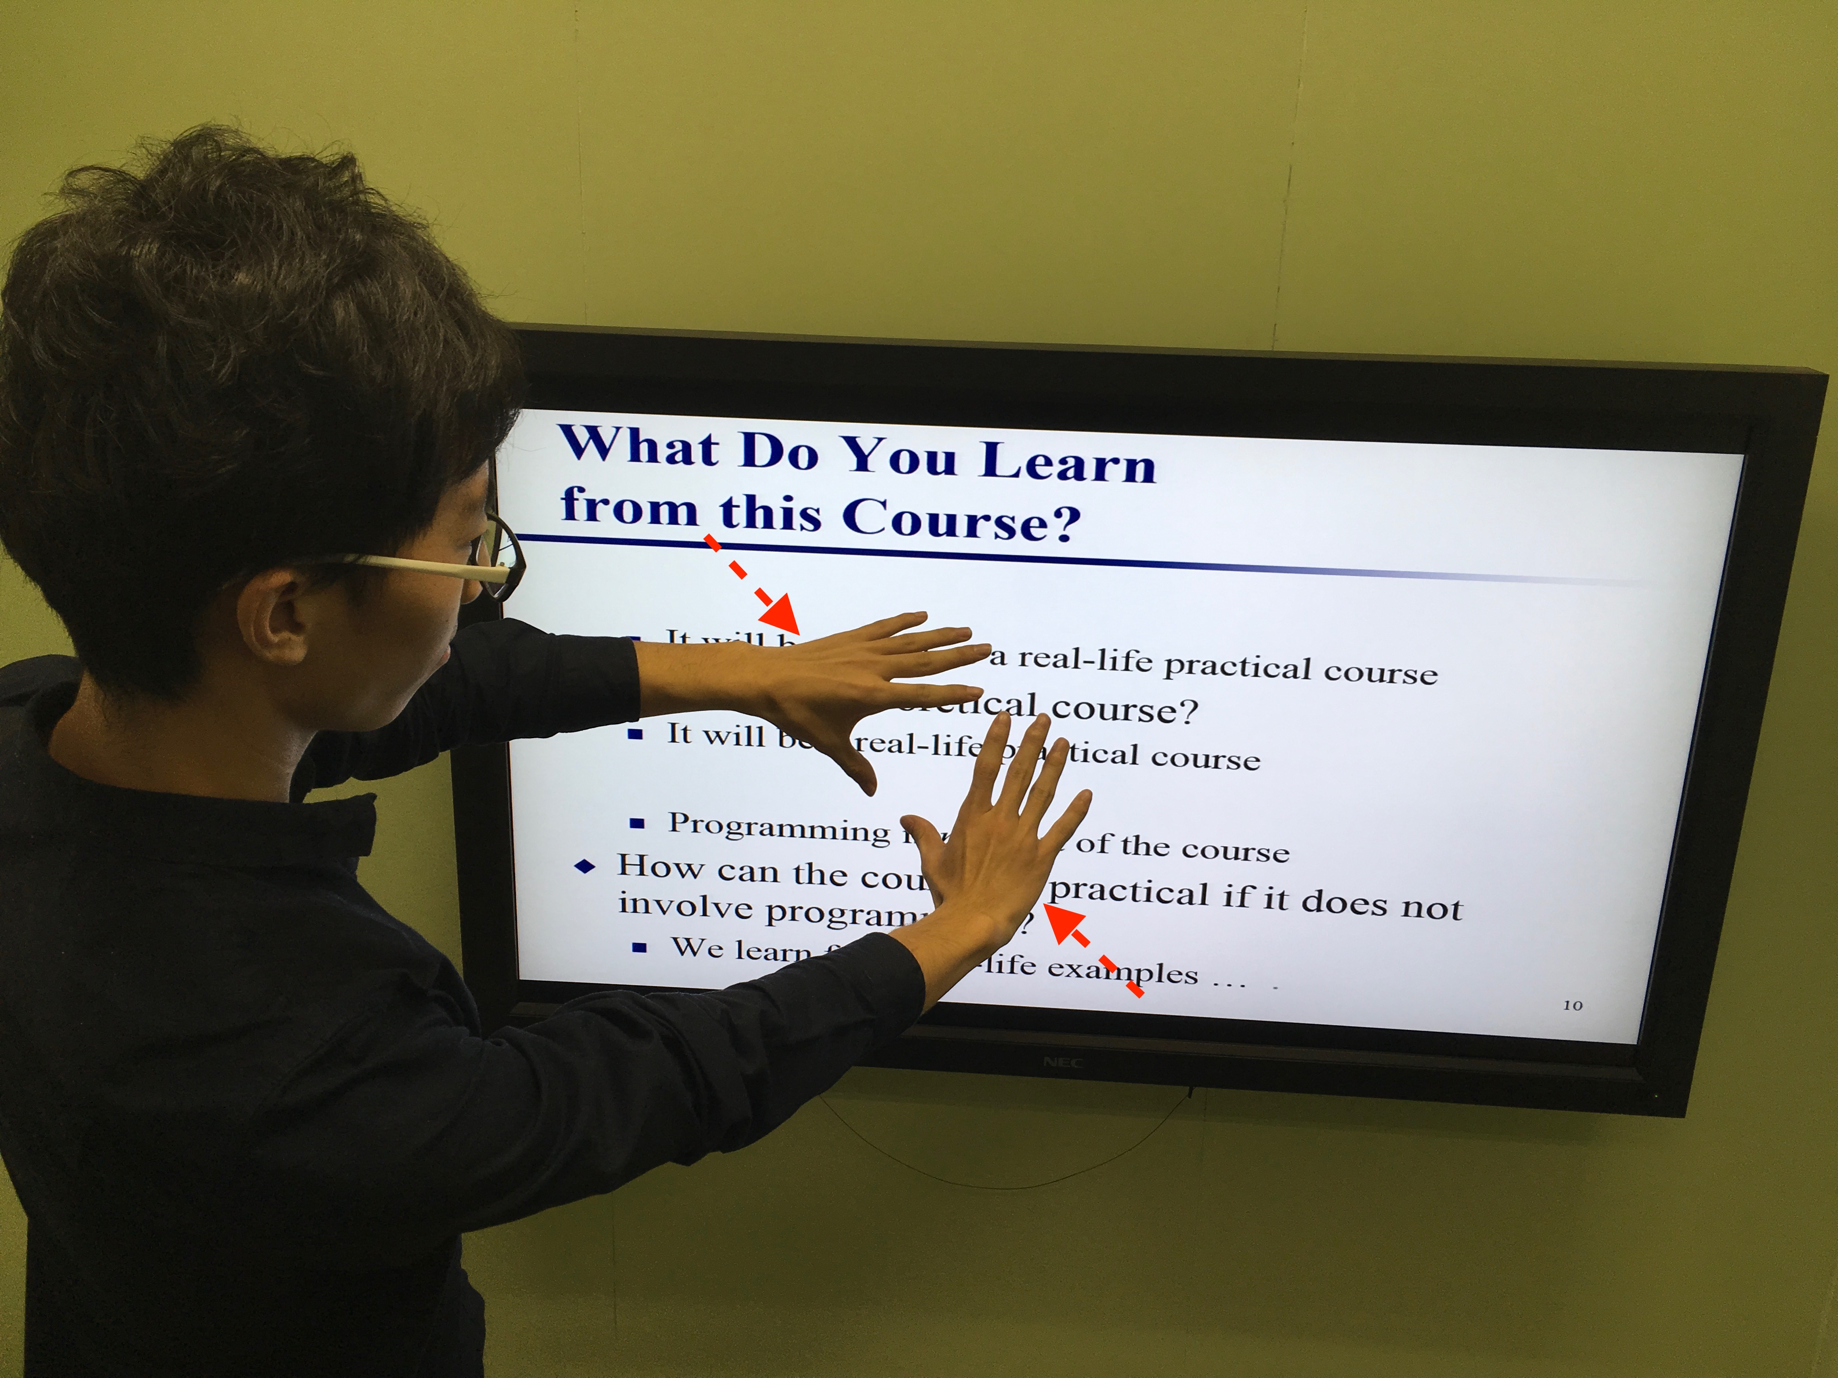

**4.2 Scenario 2 Play games**

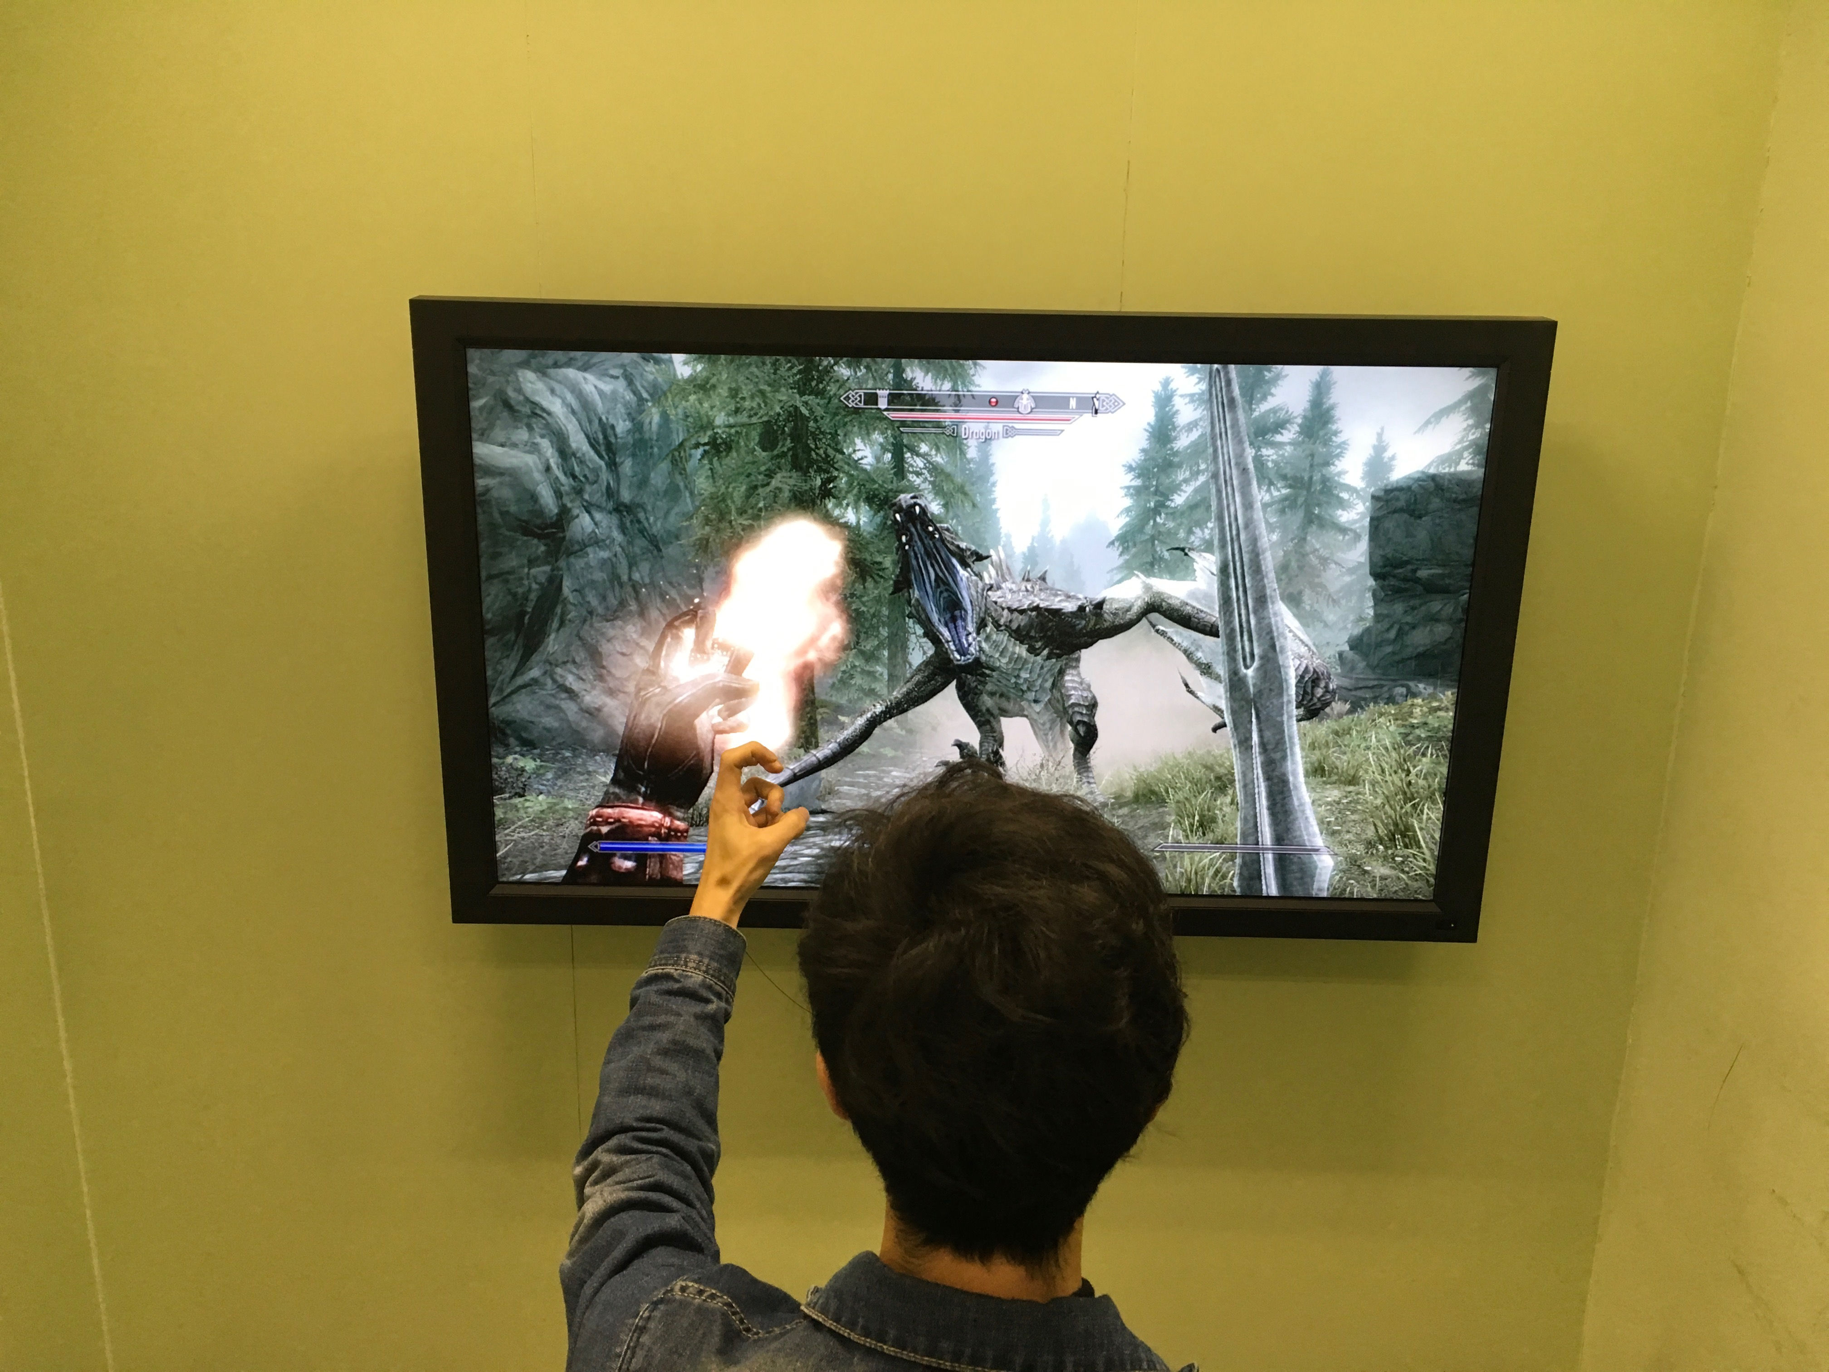

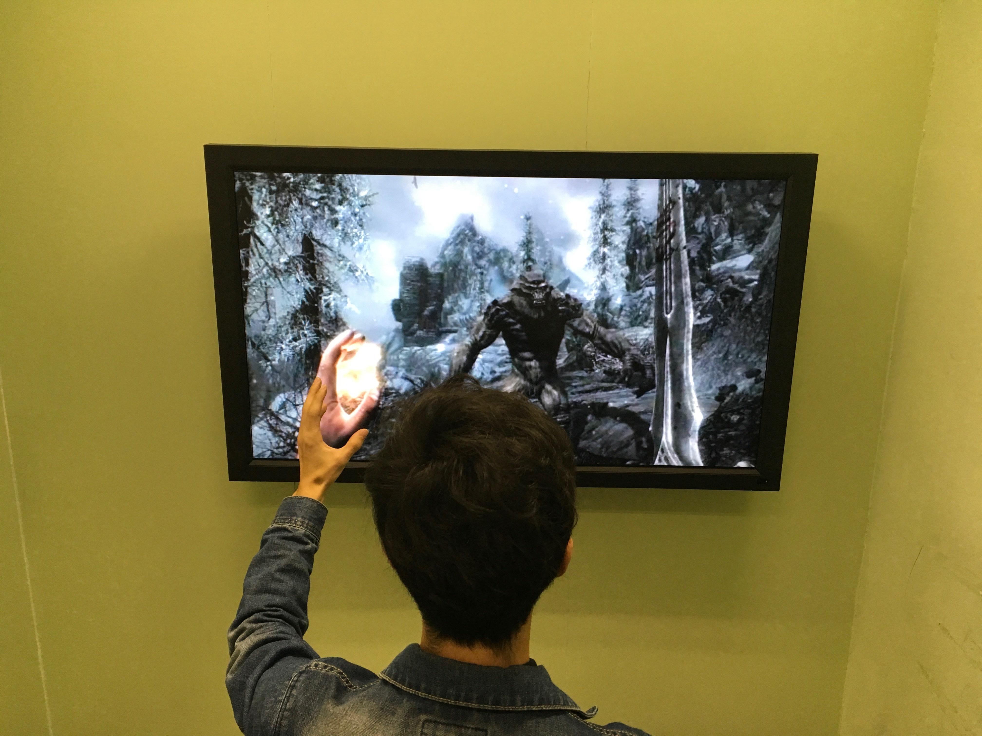

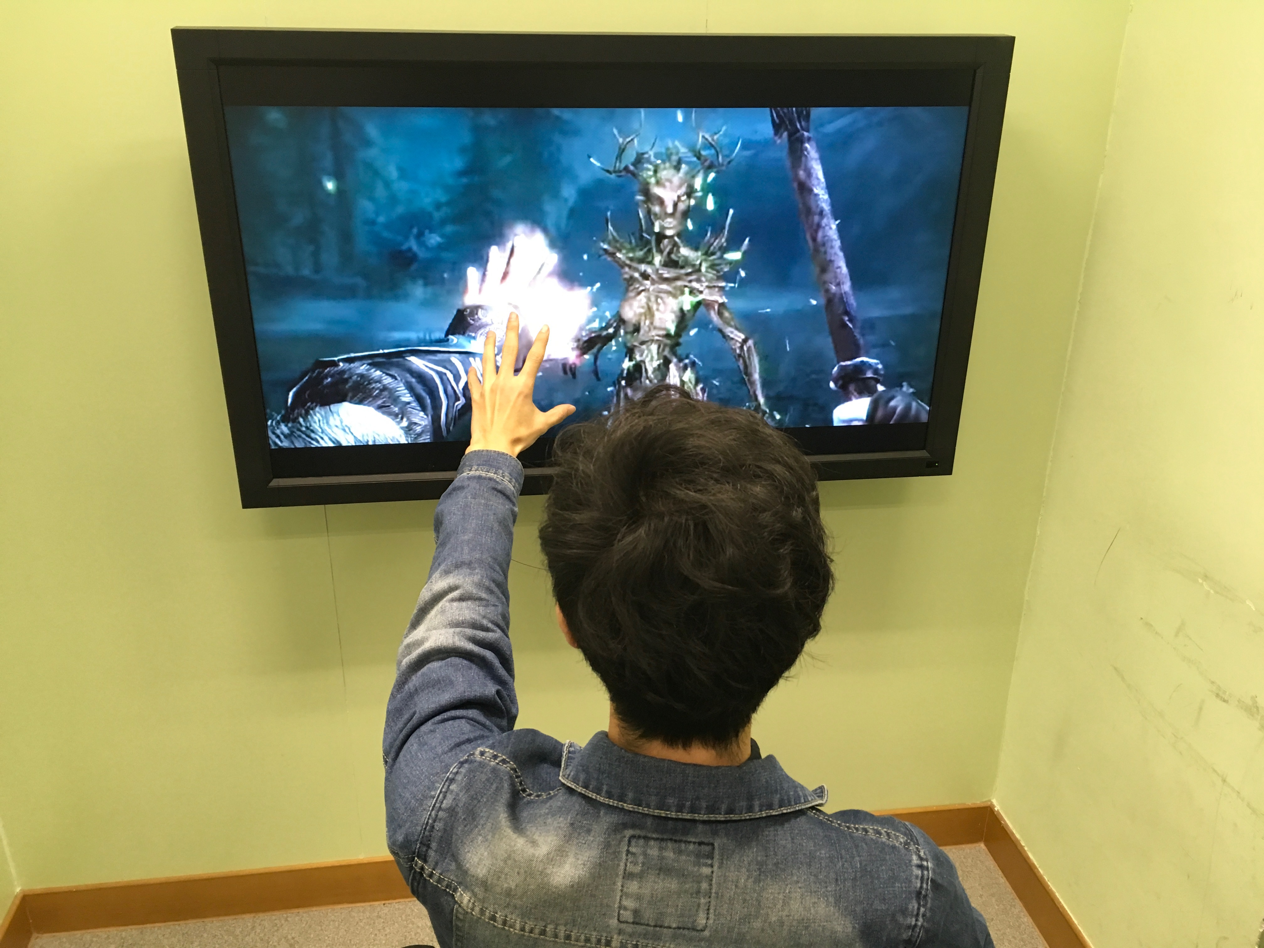

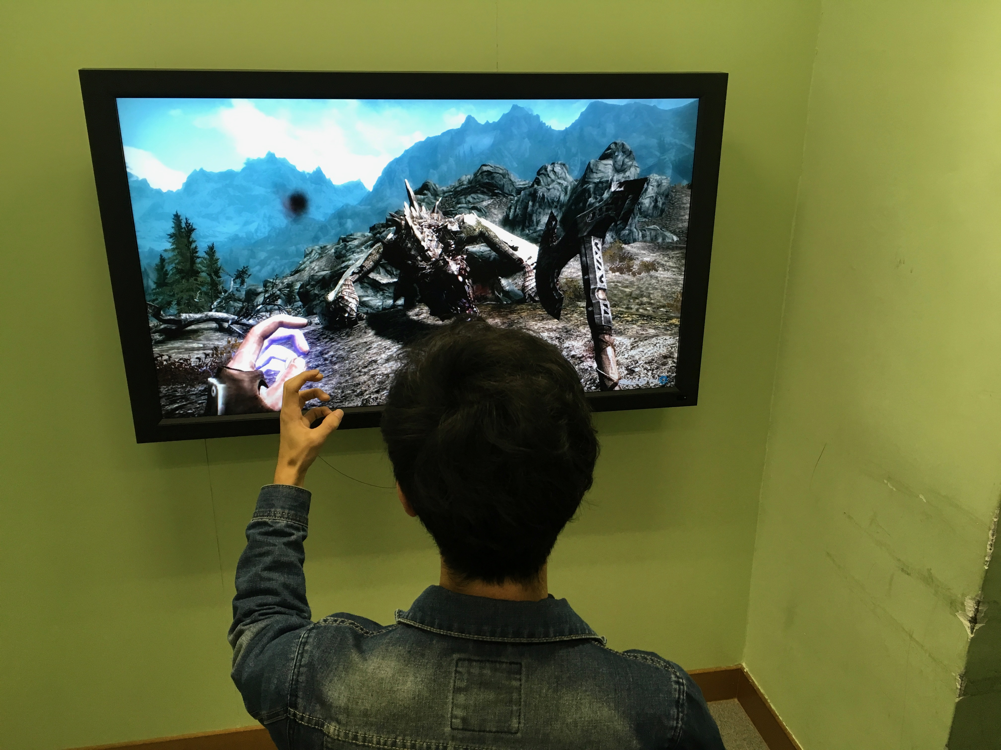

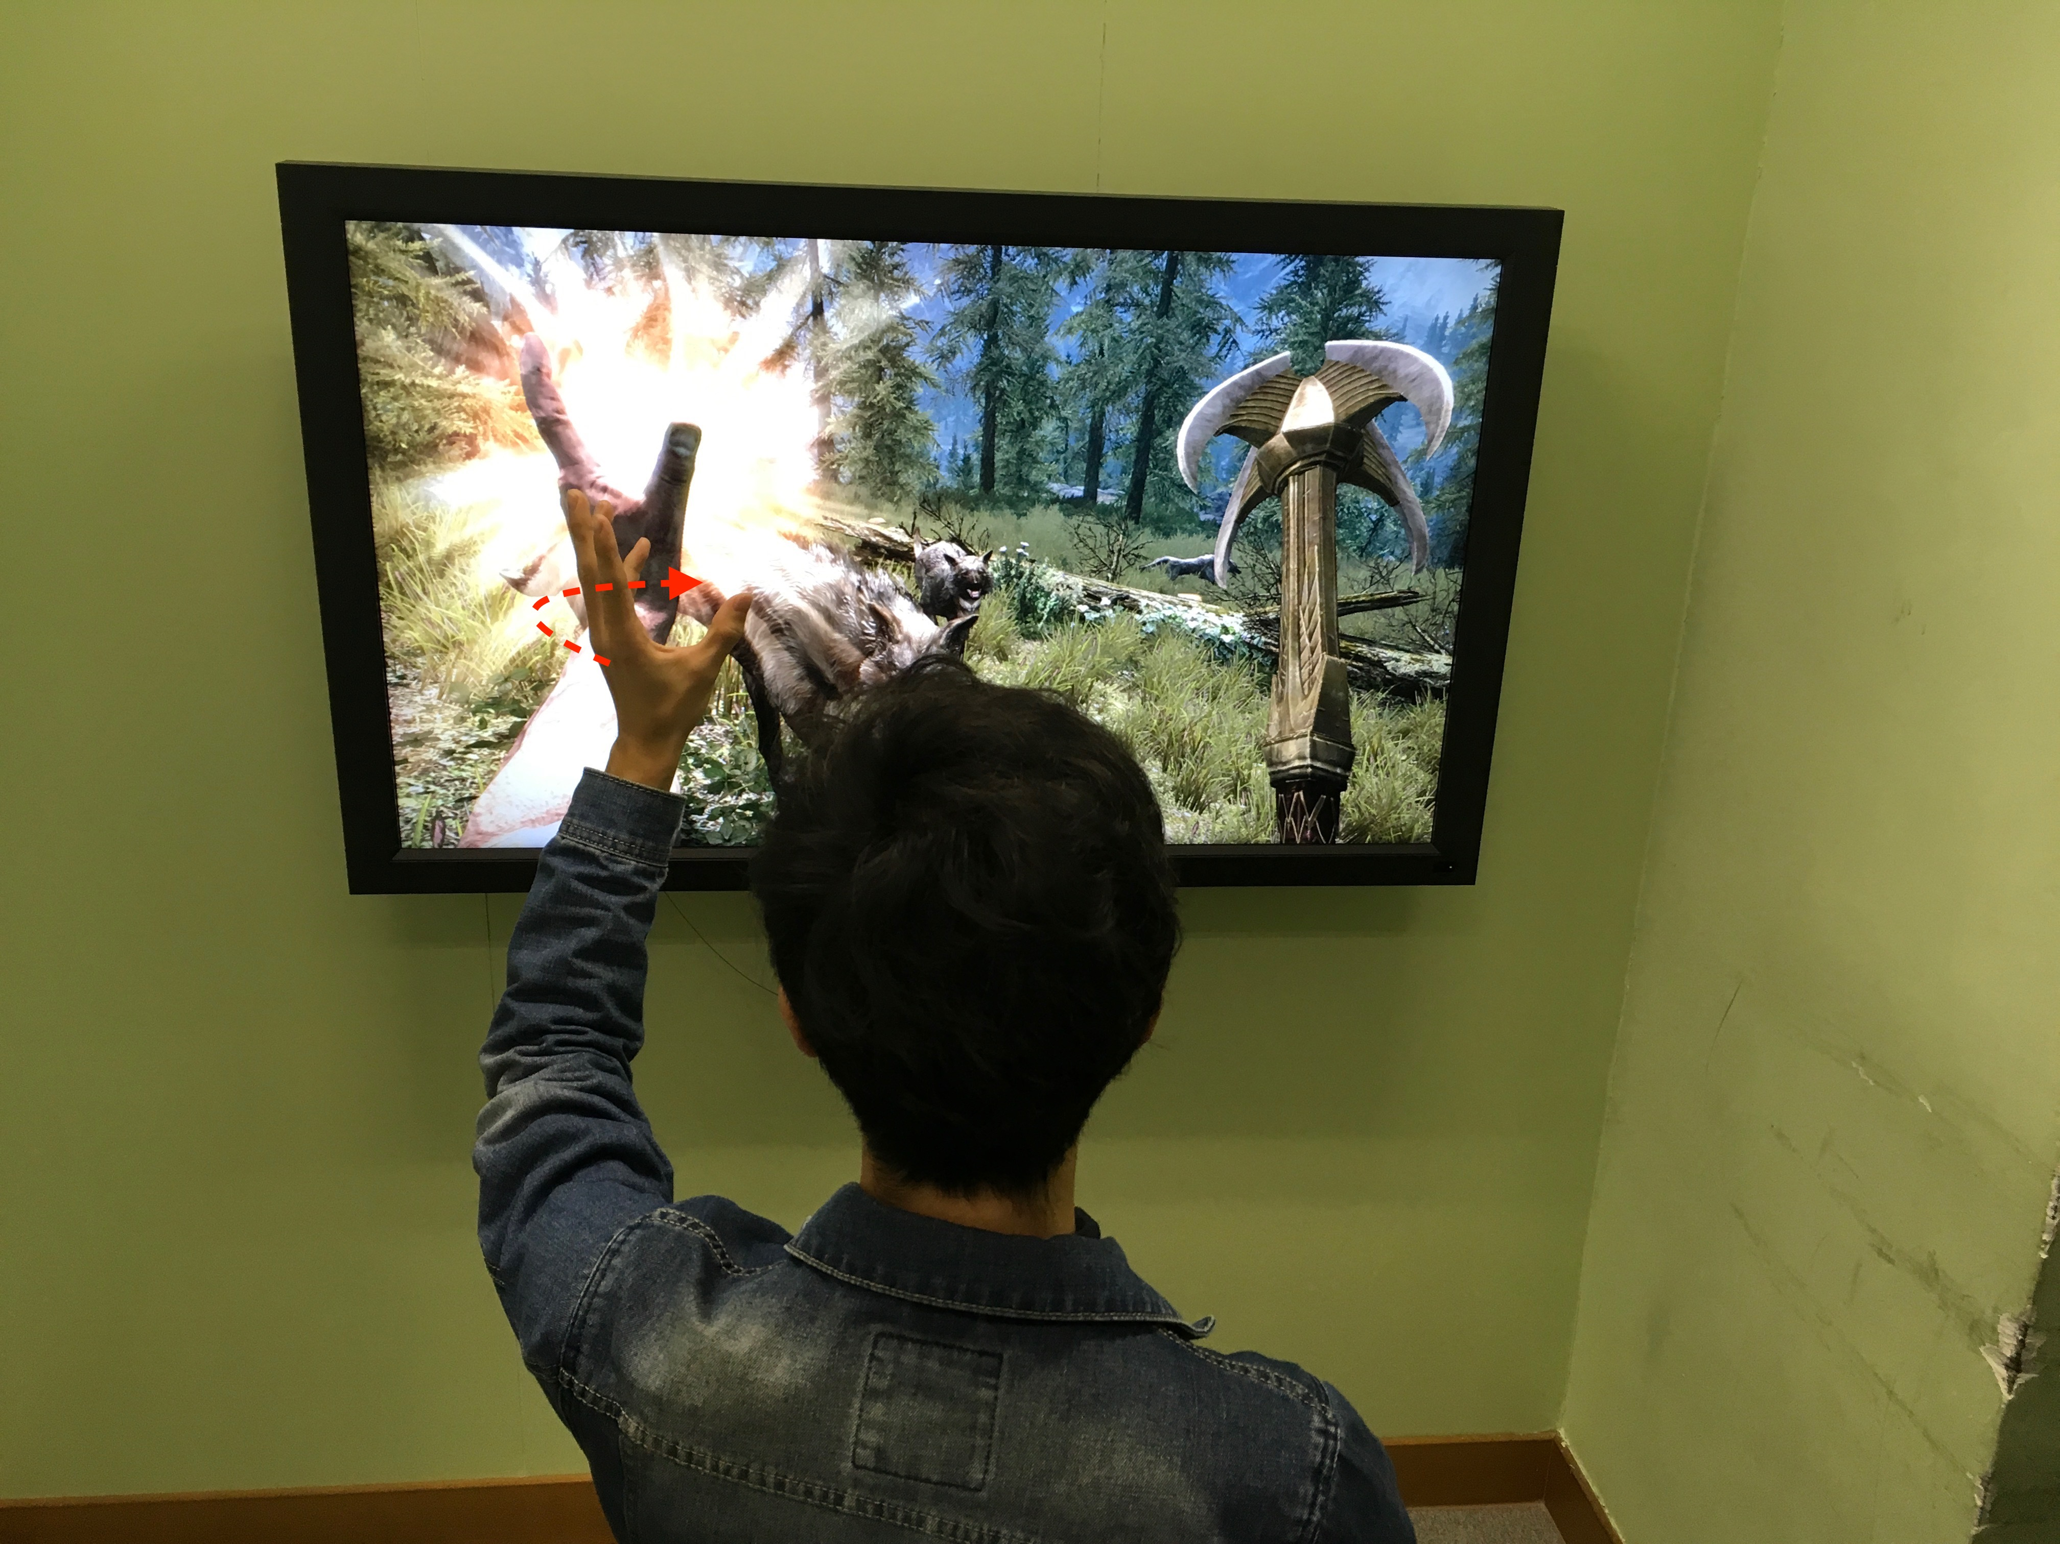

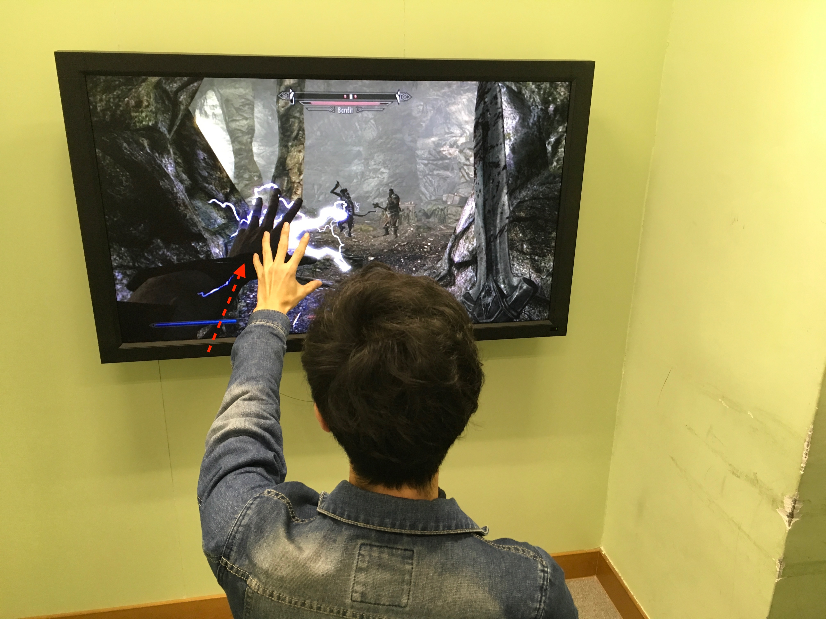

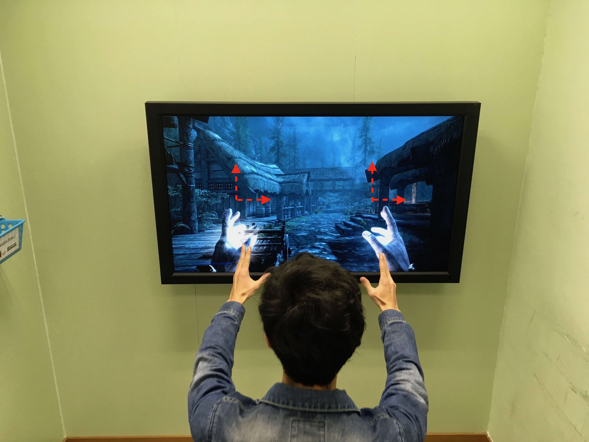

**4.3 Scenario 3 Make a phone call**

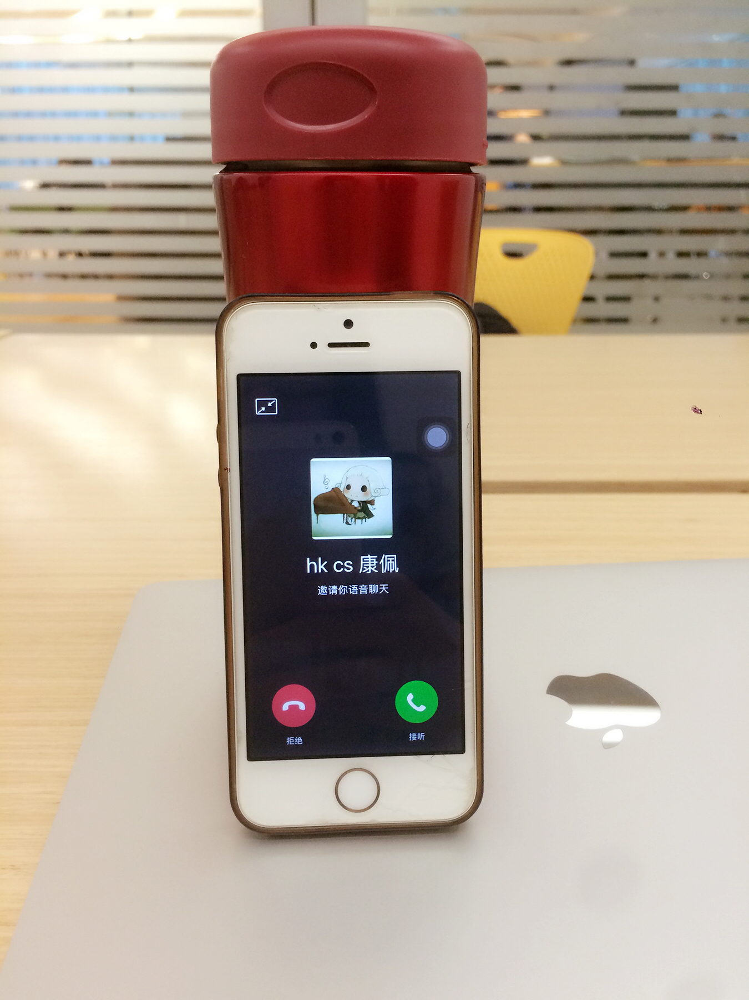

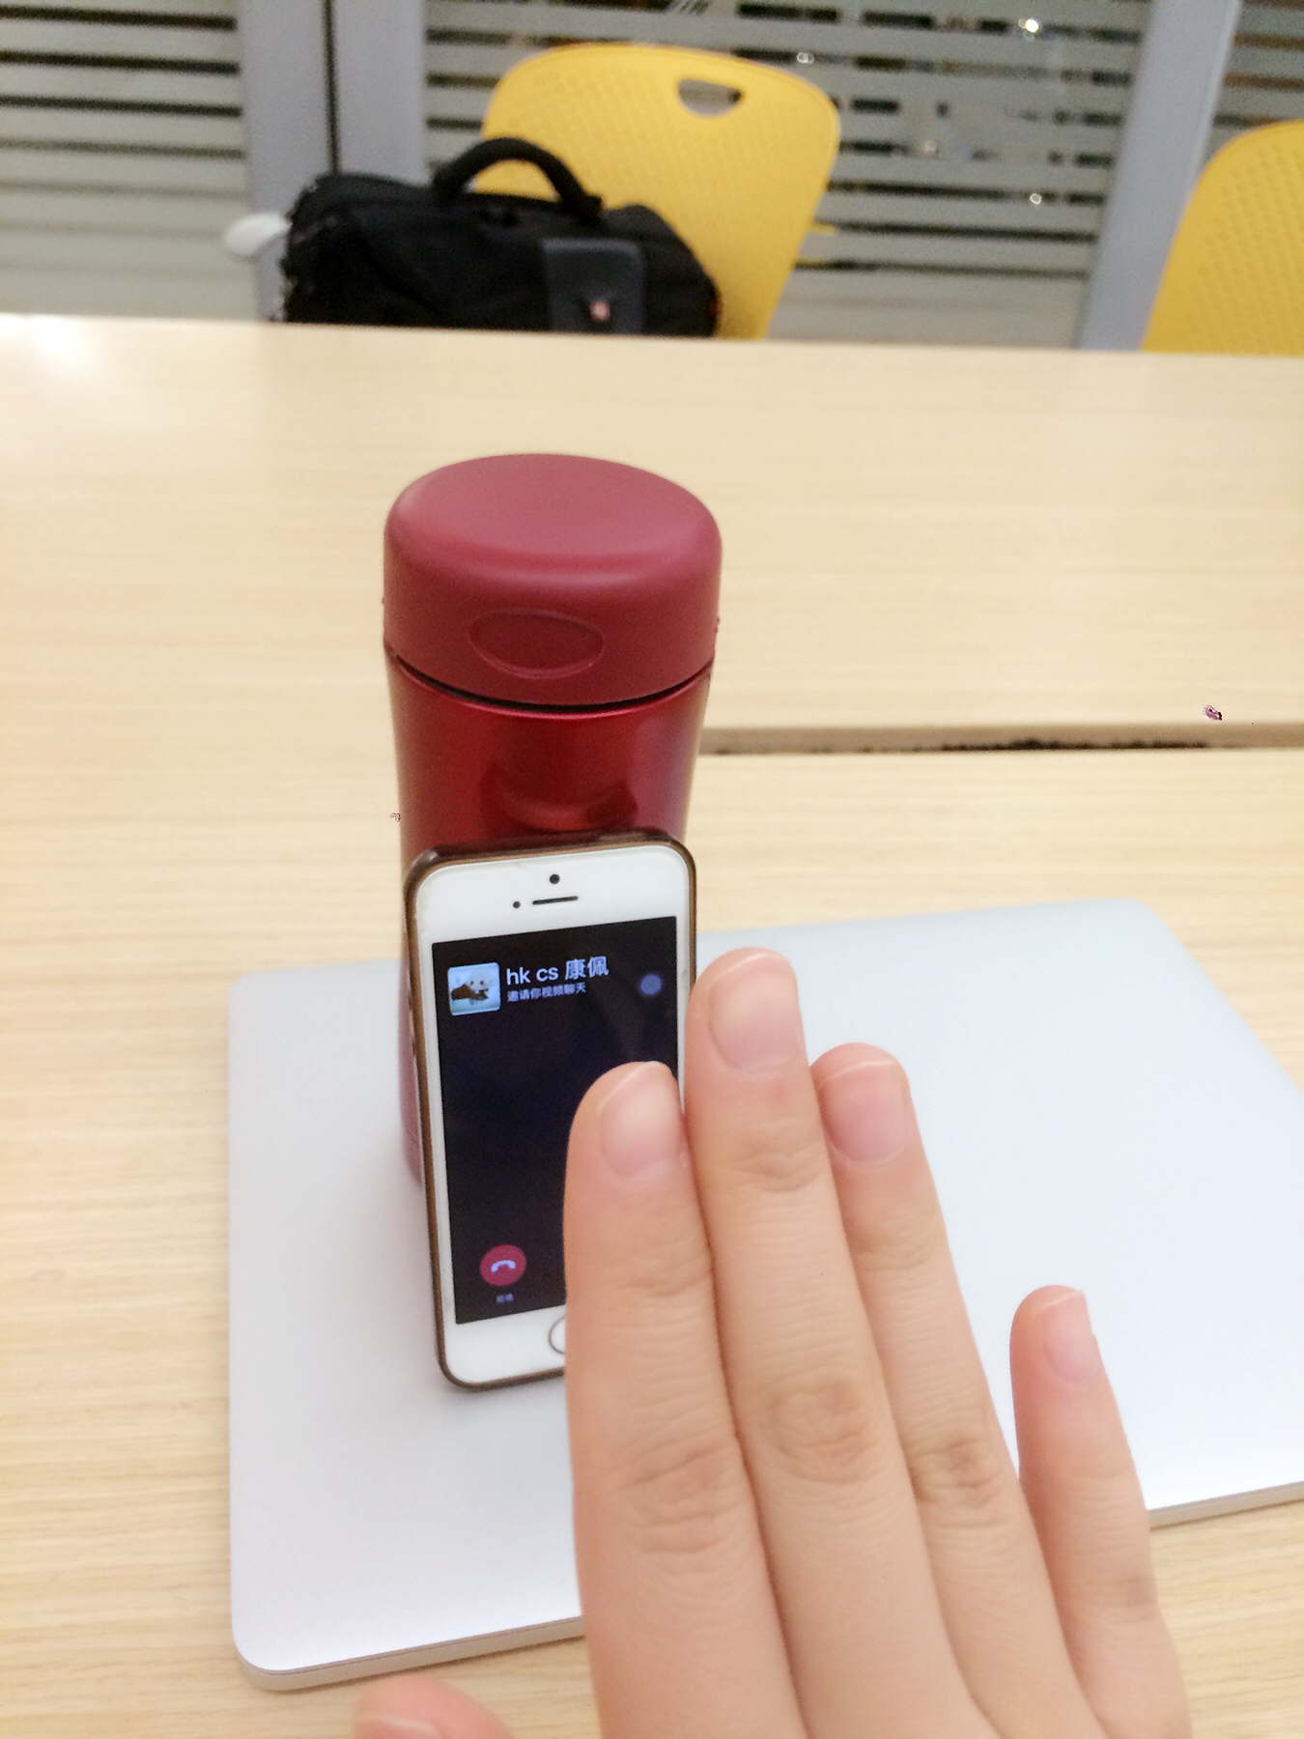

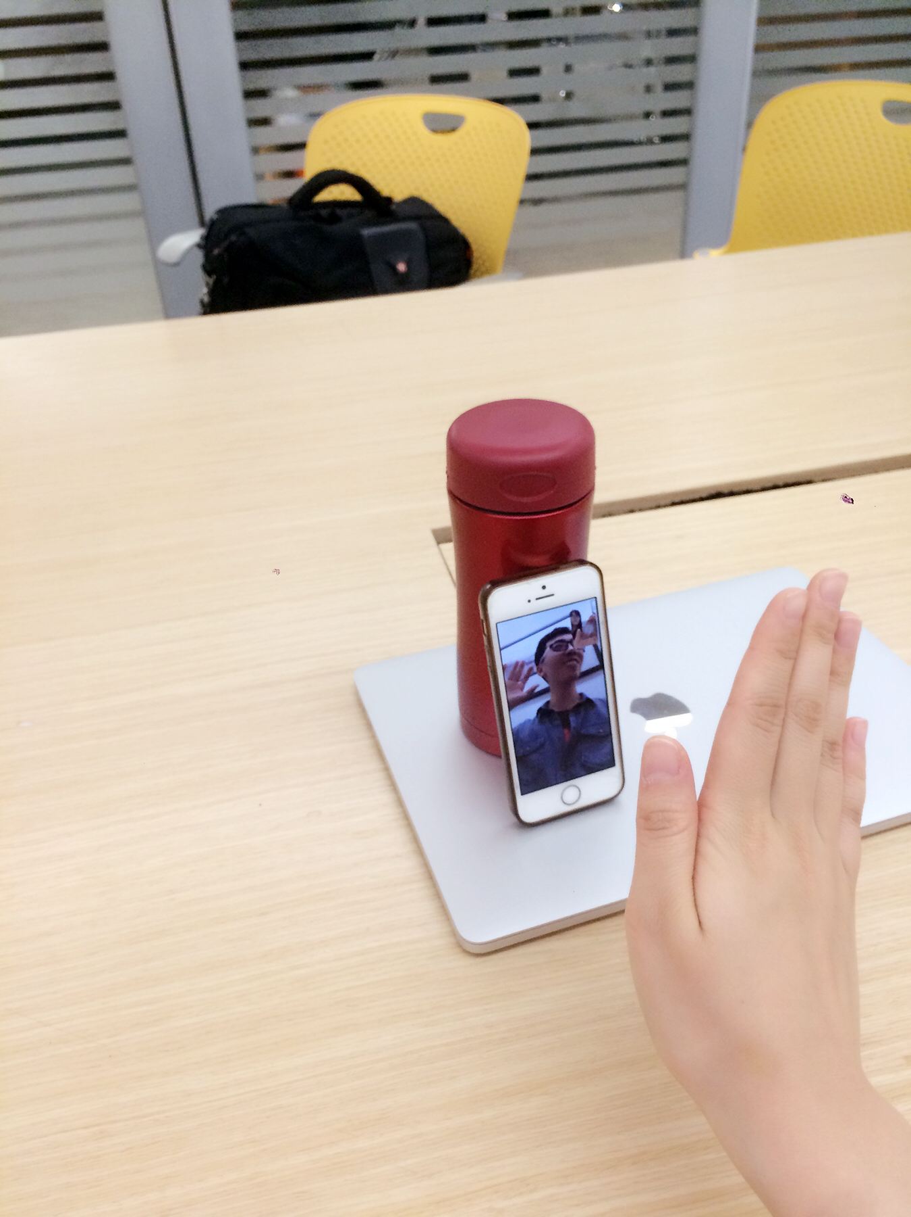

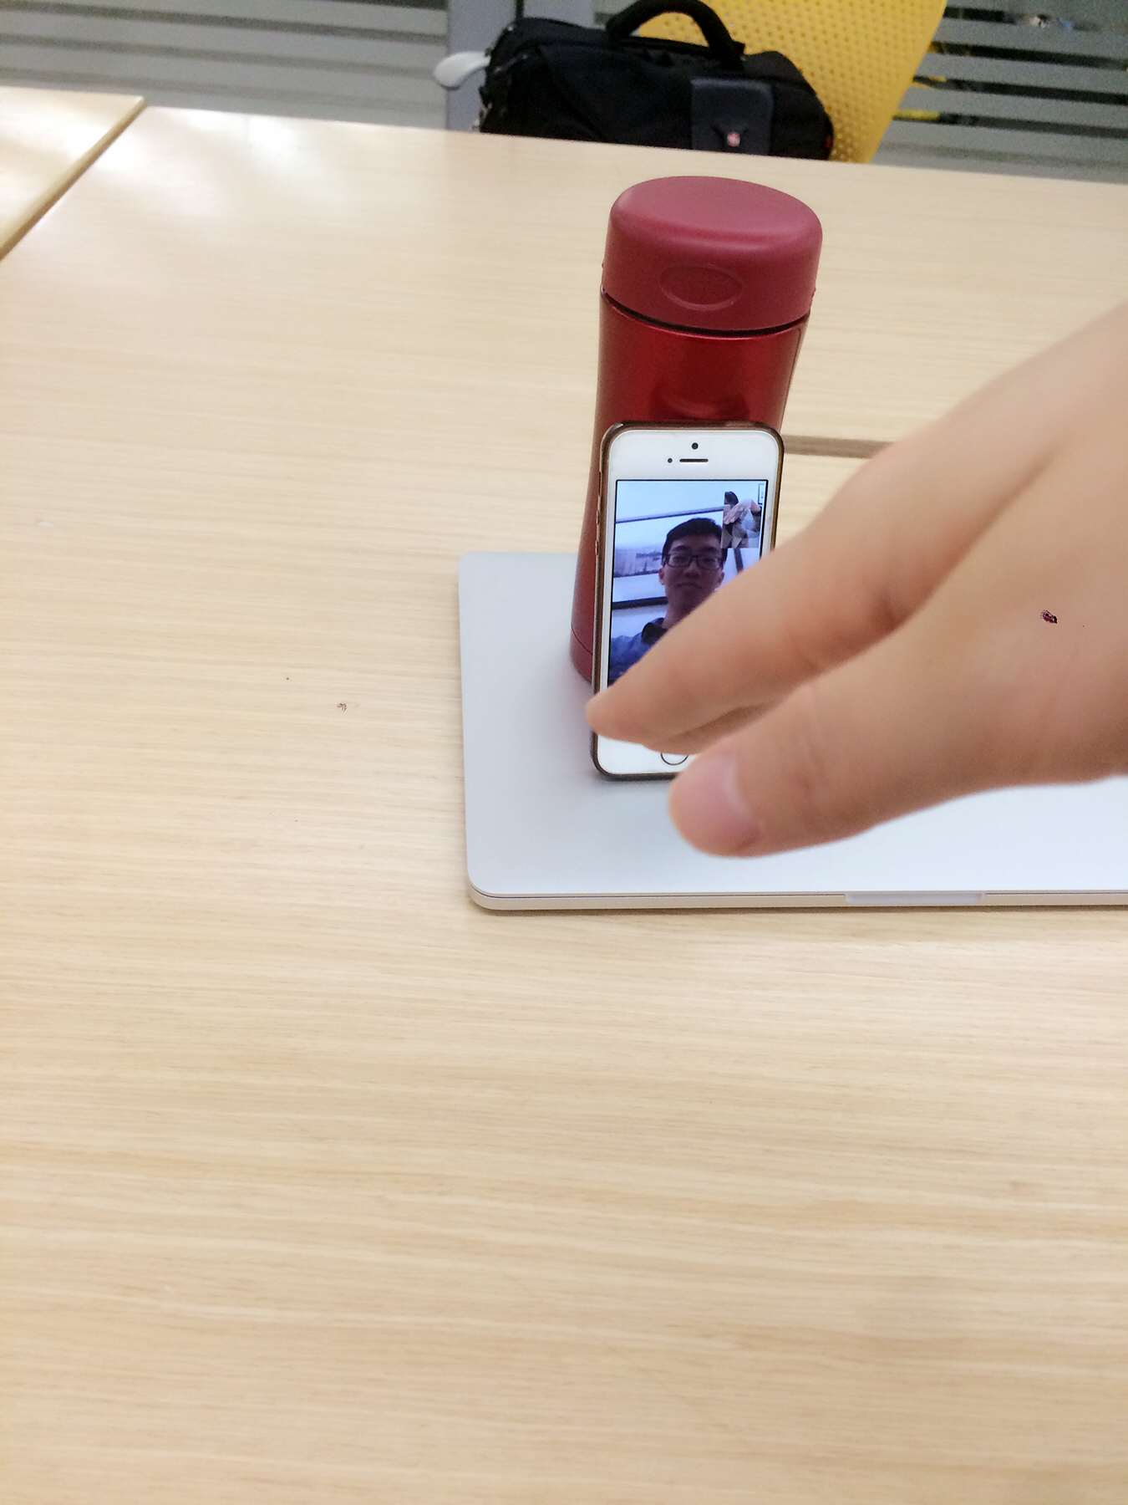

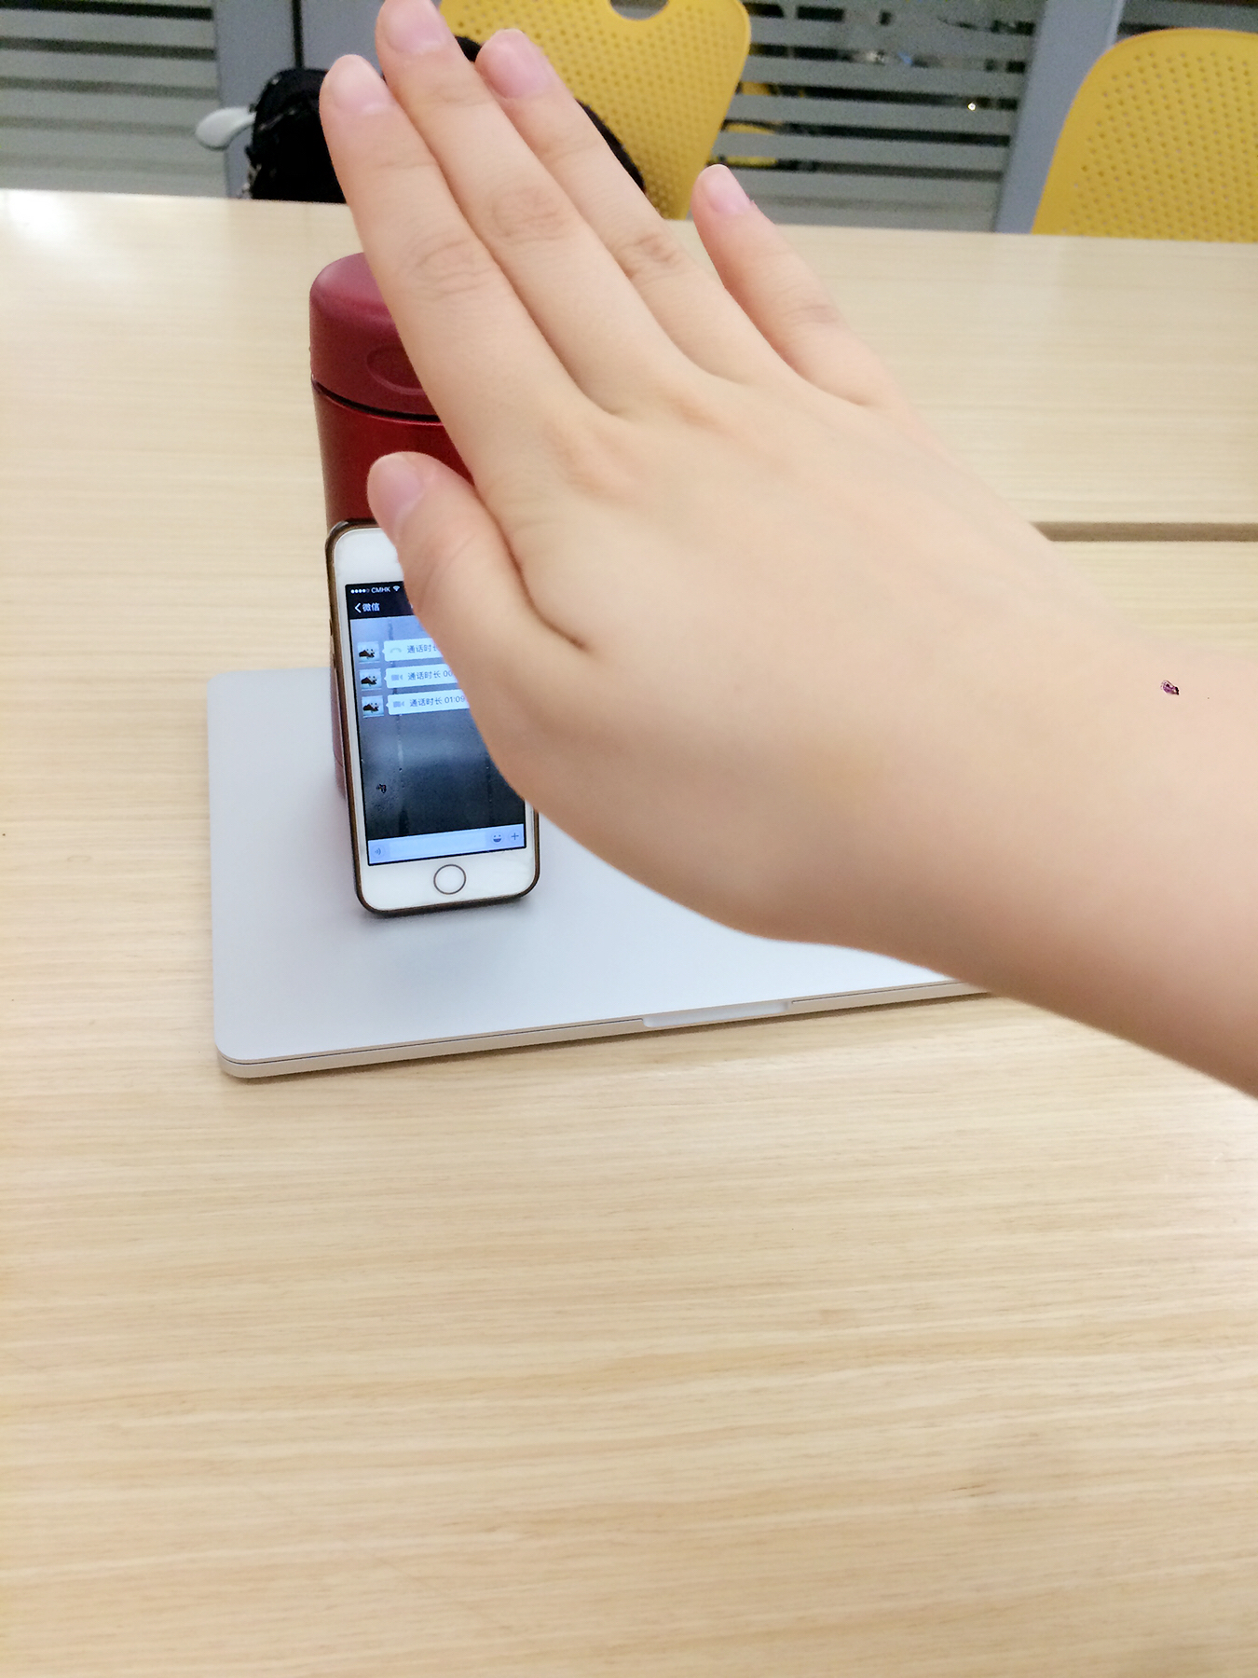

**4.4 Scenario 4 Computer operation**

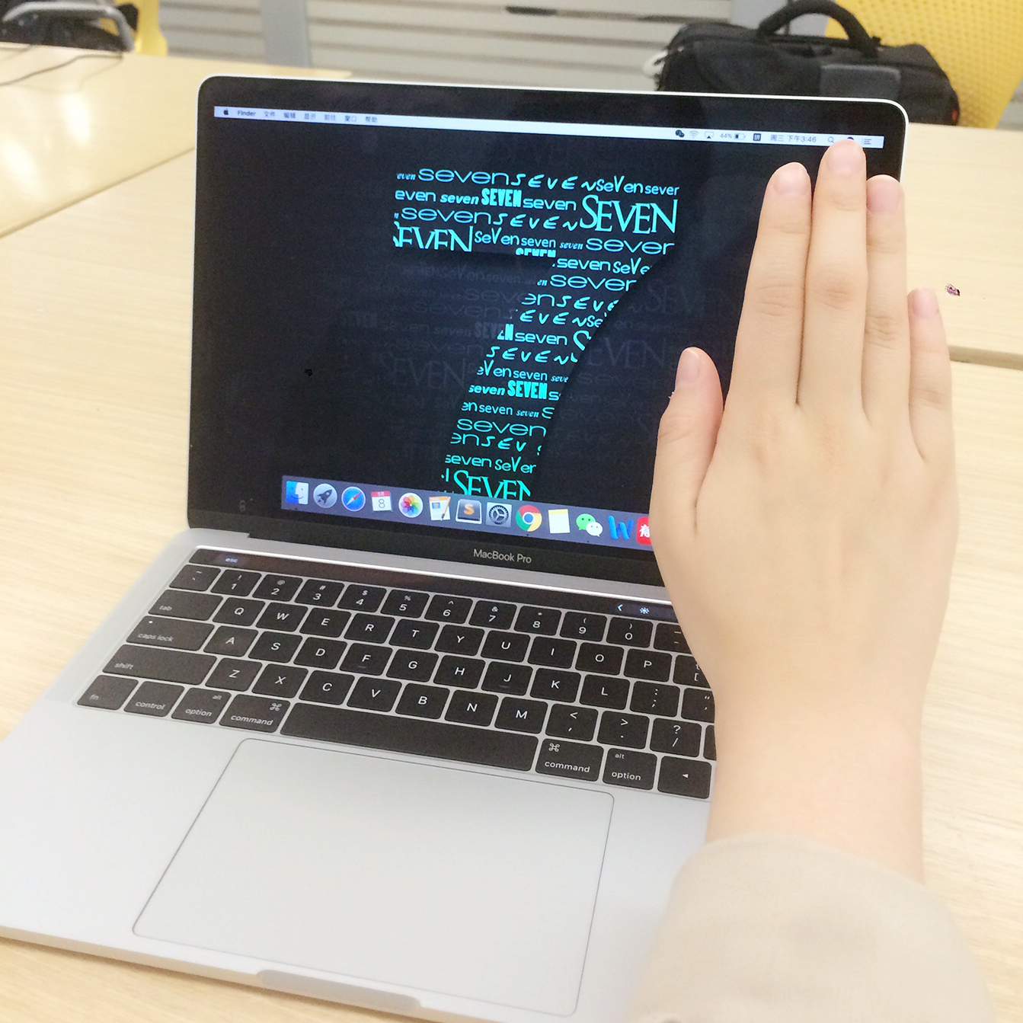

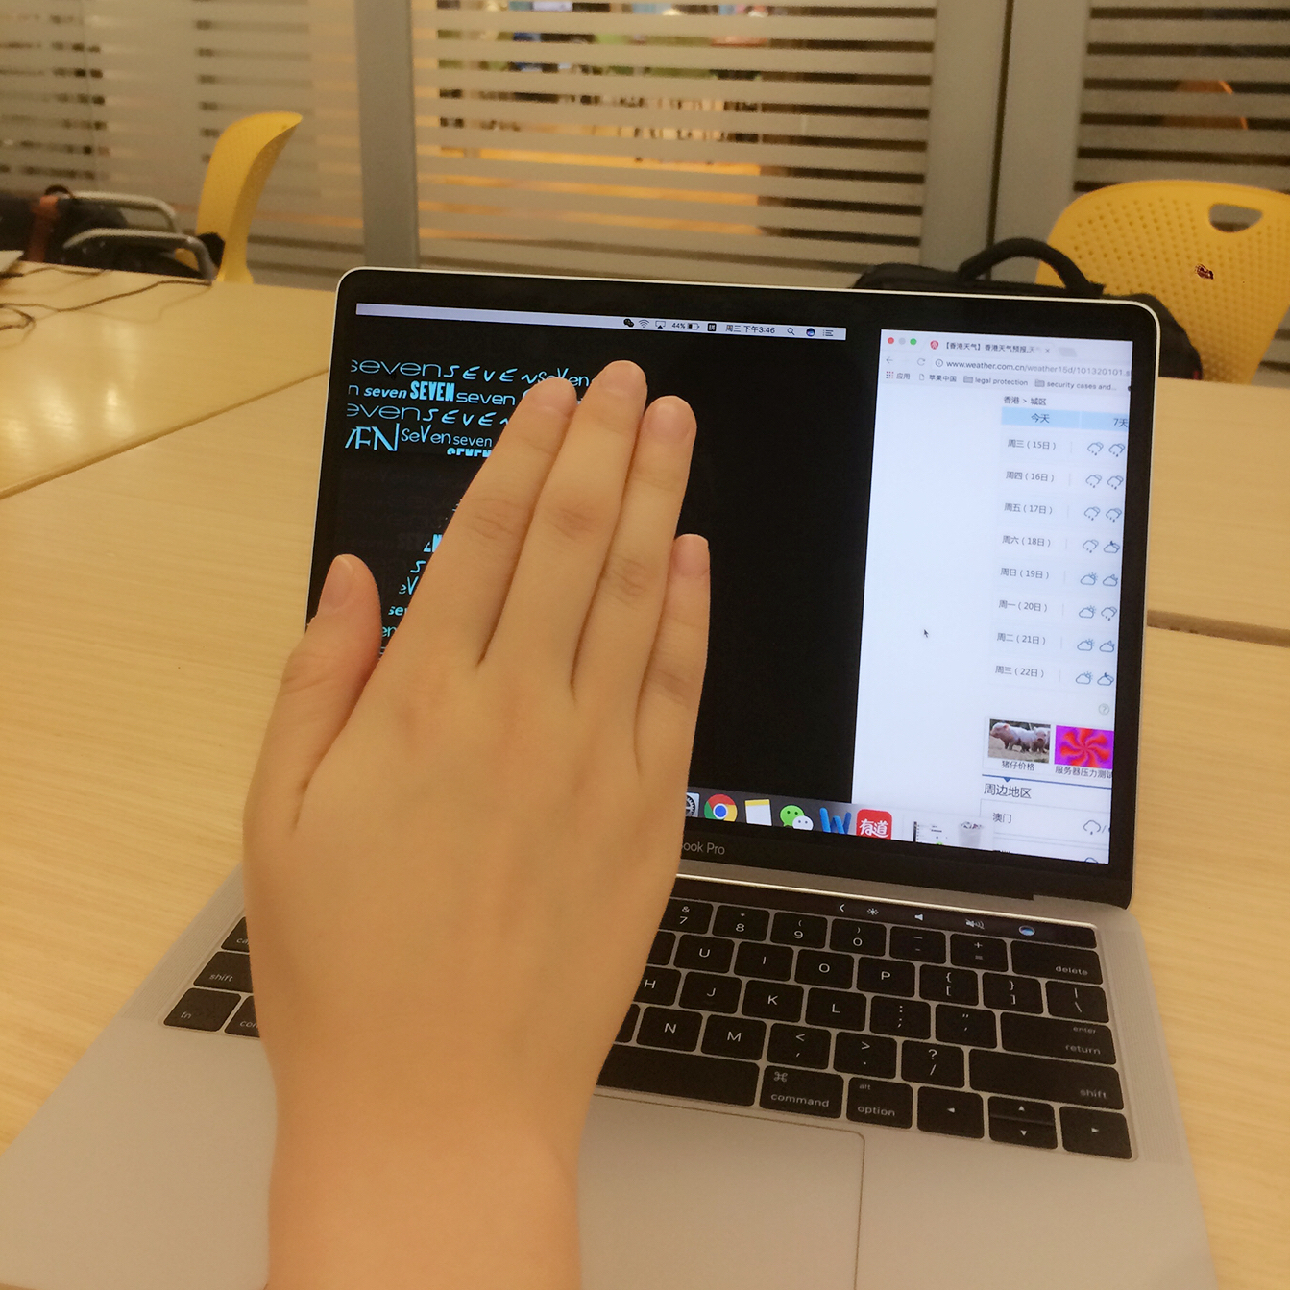

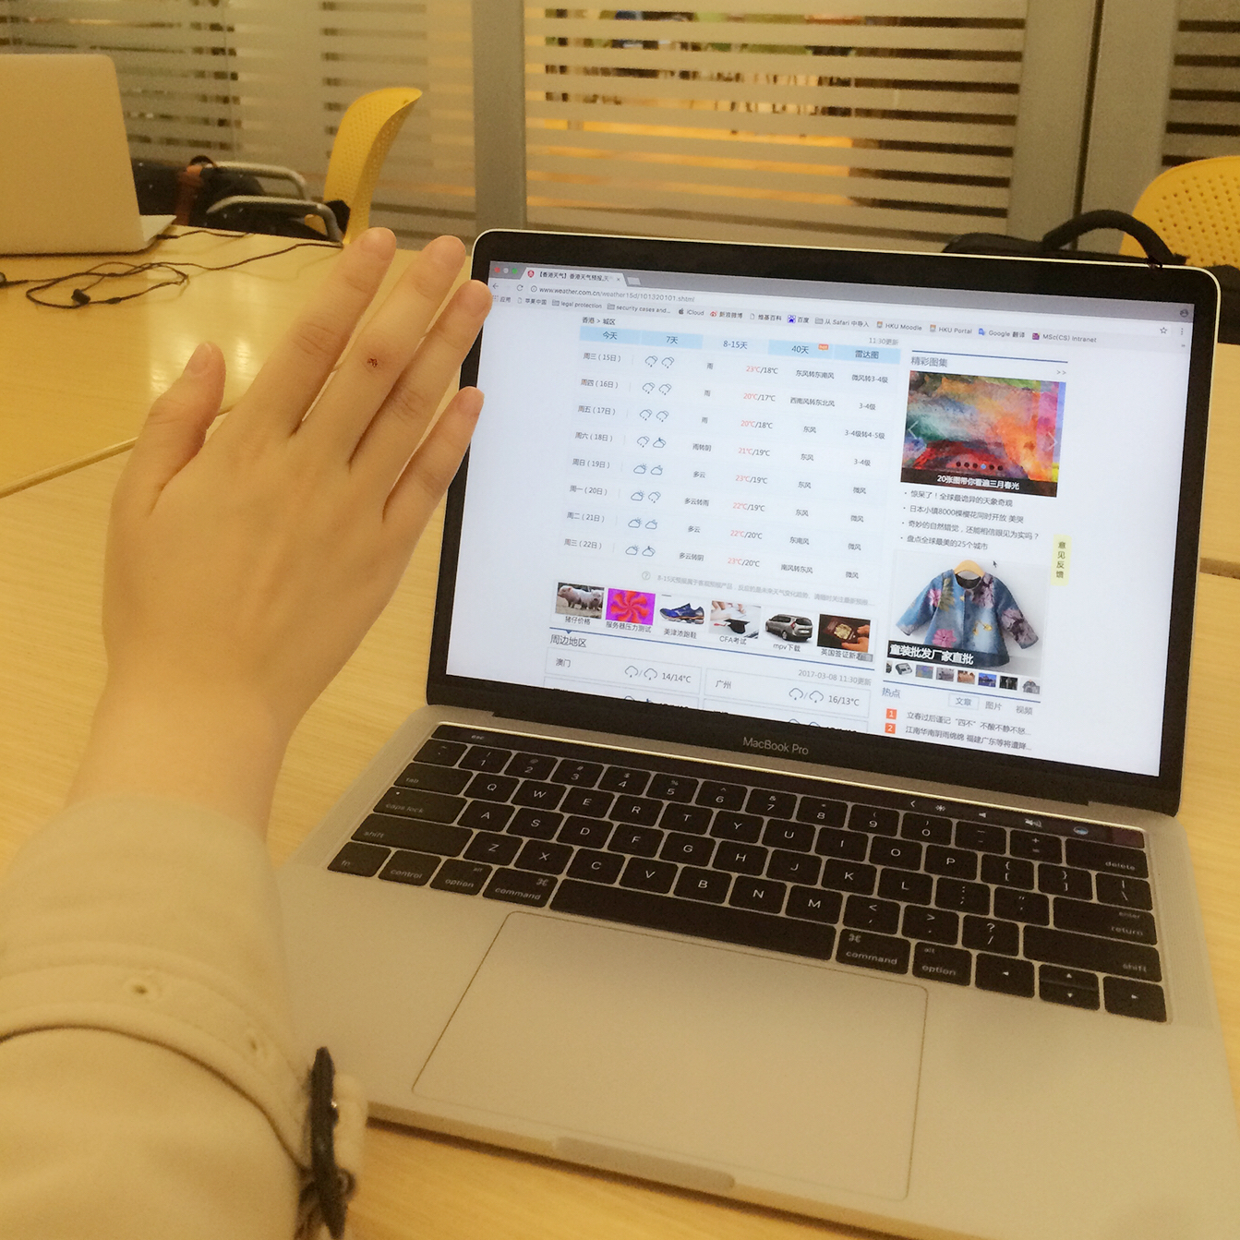

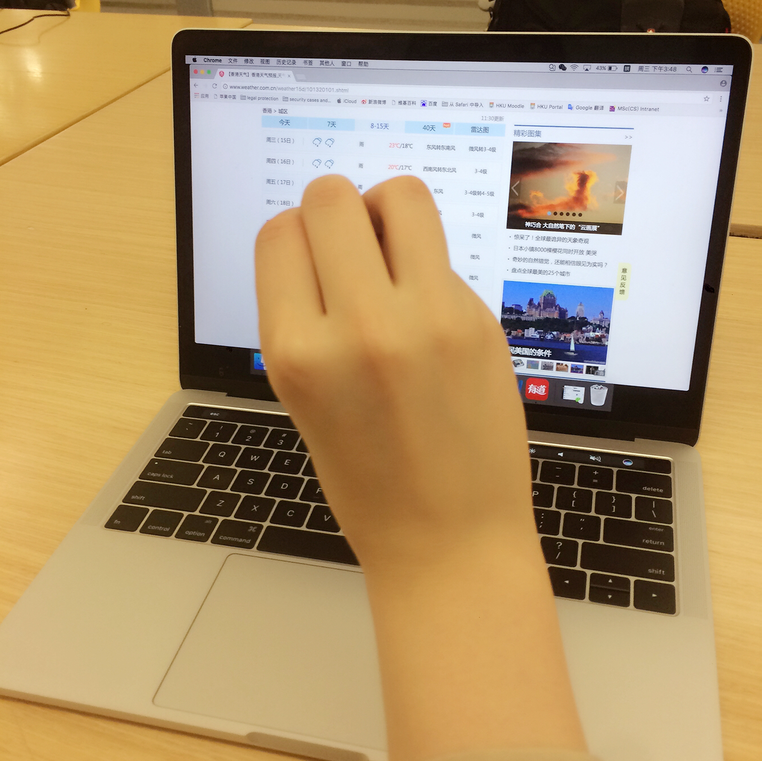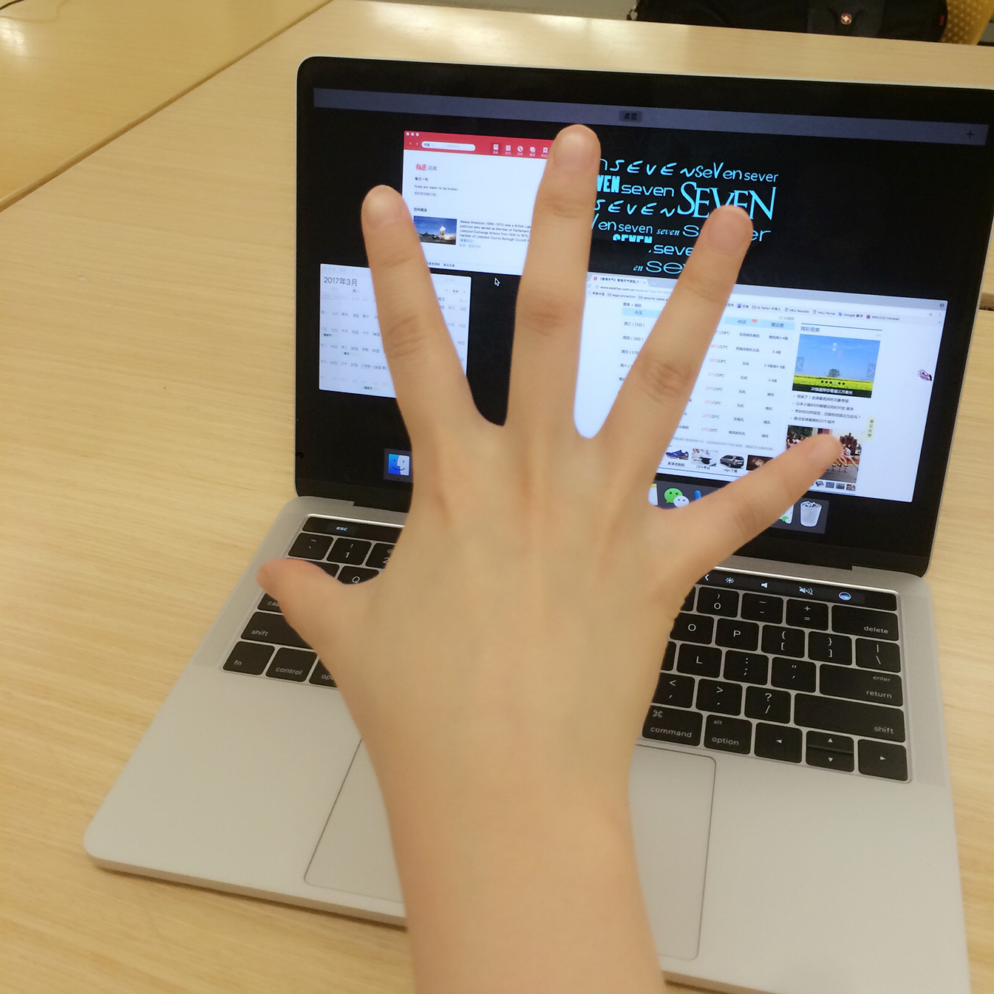

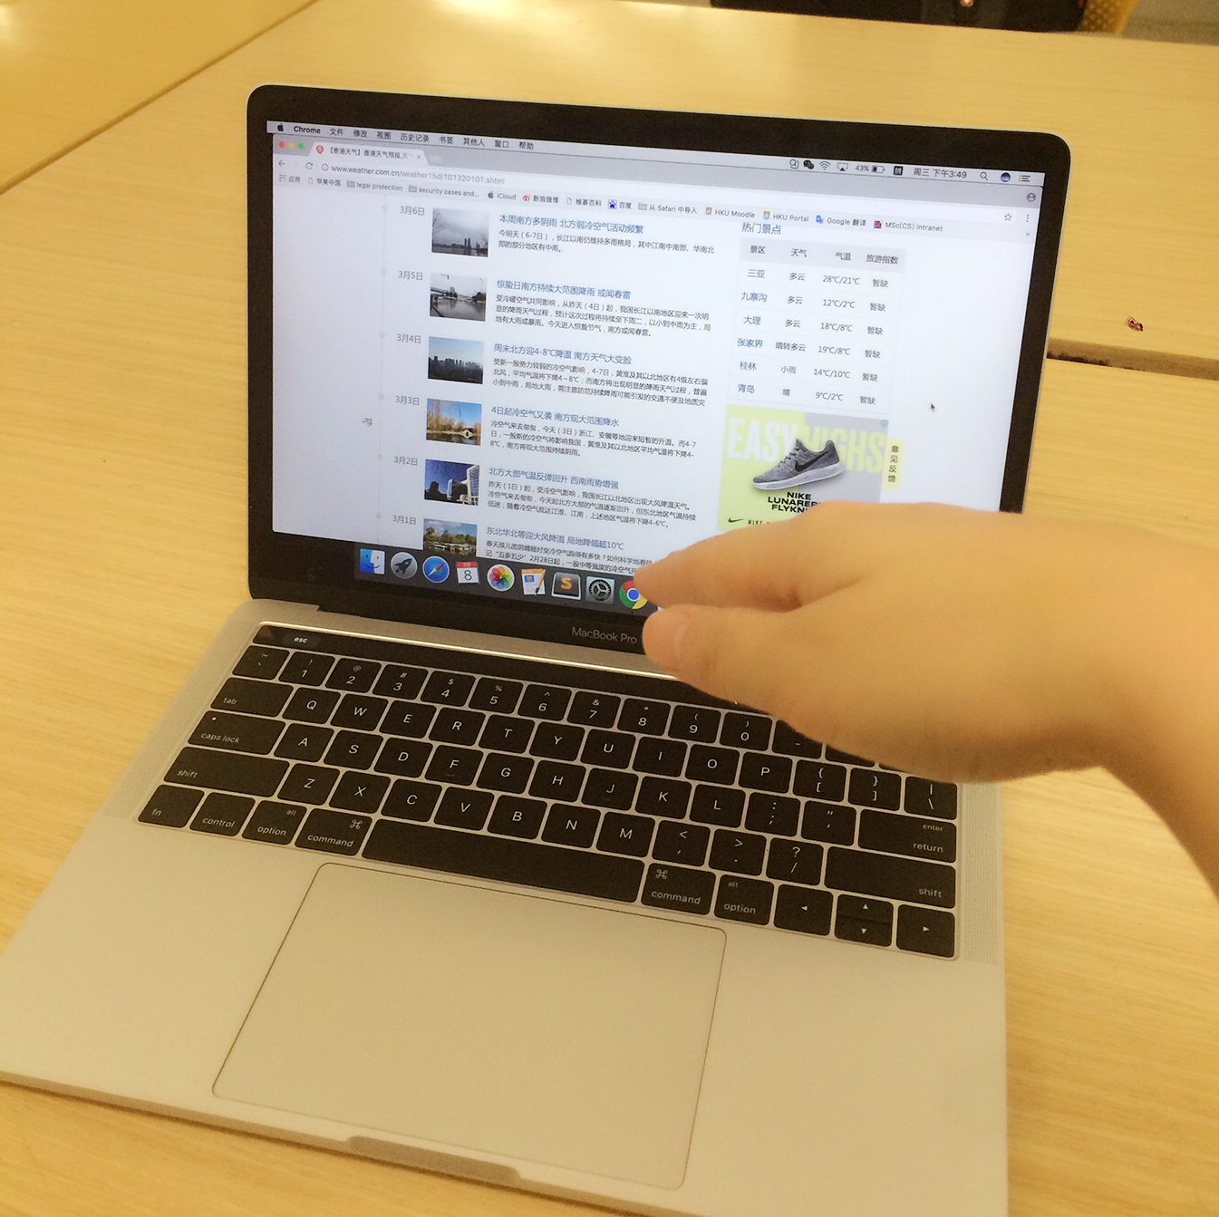

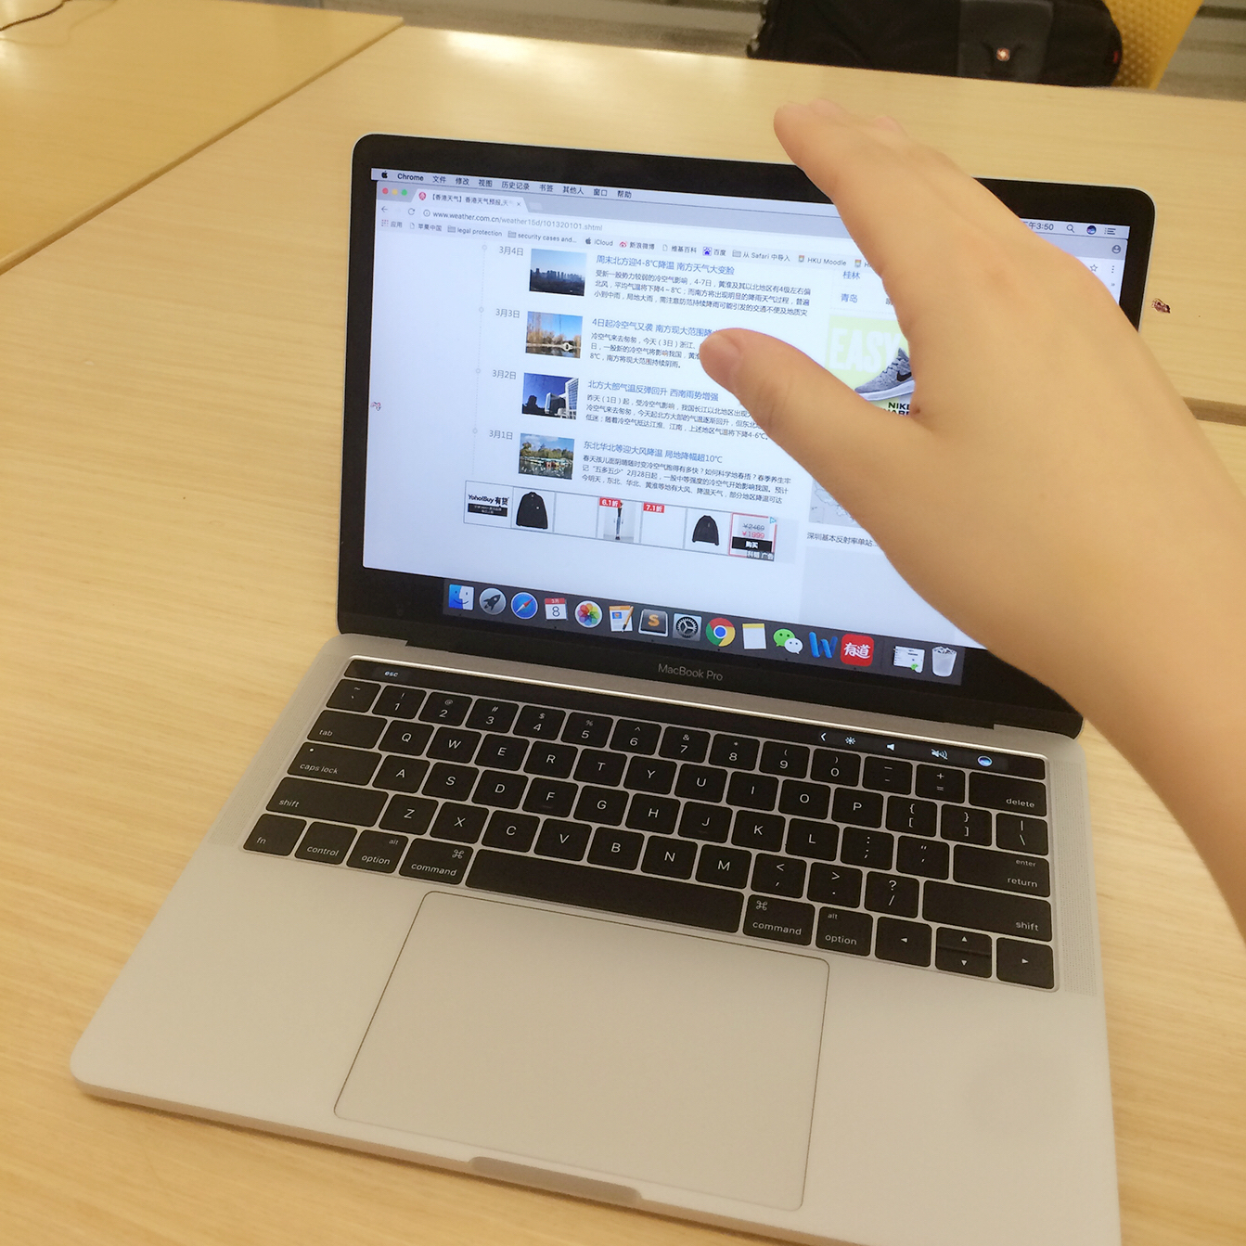

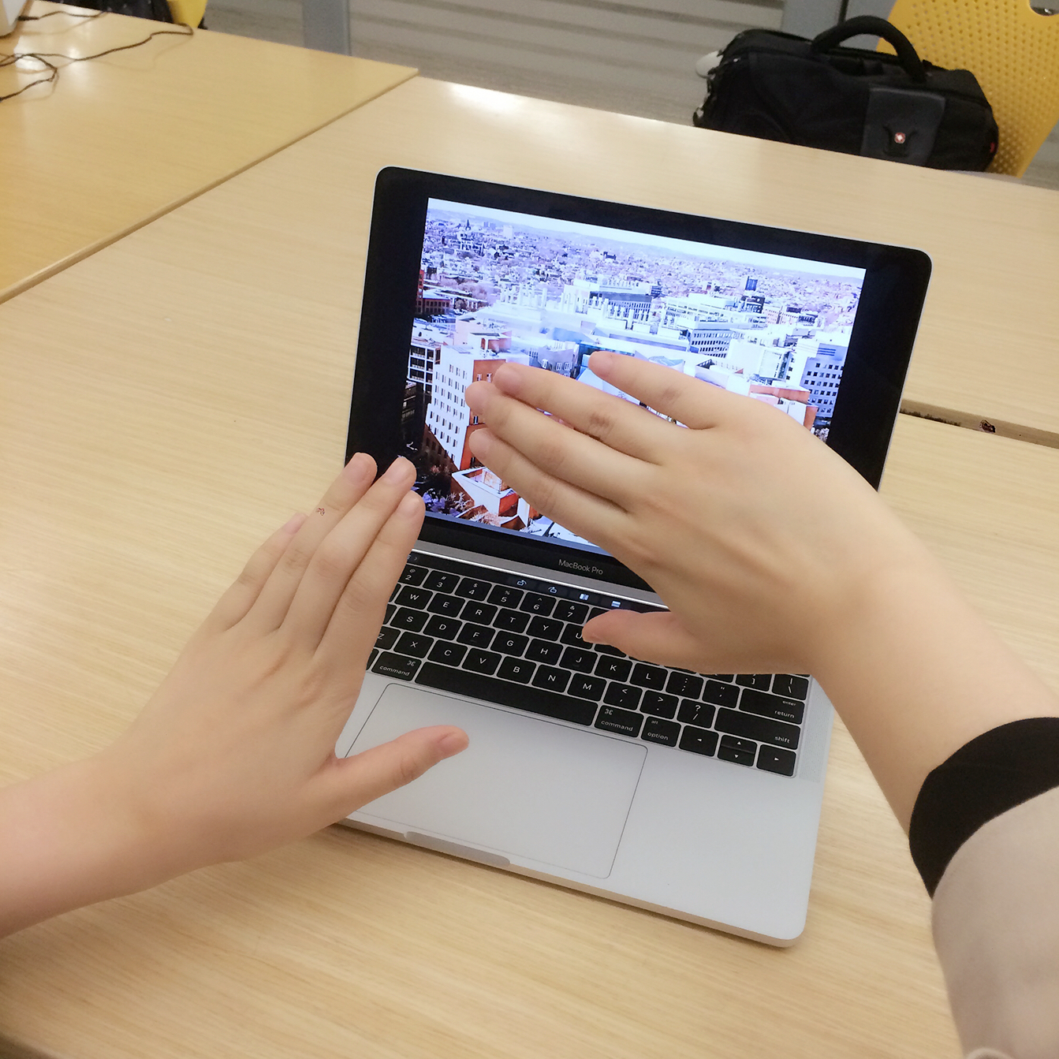

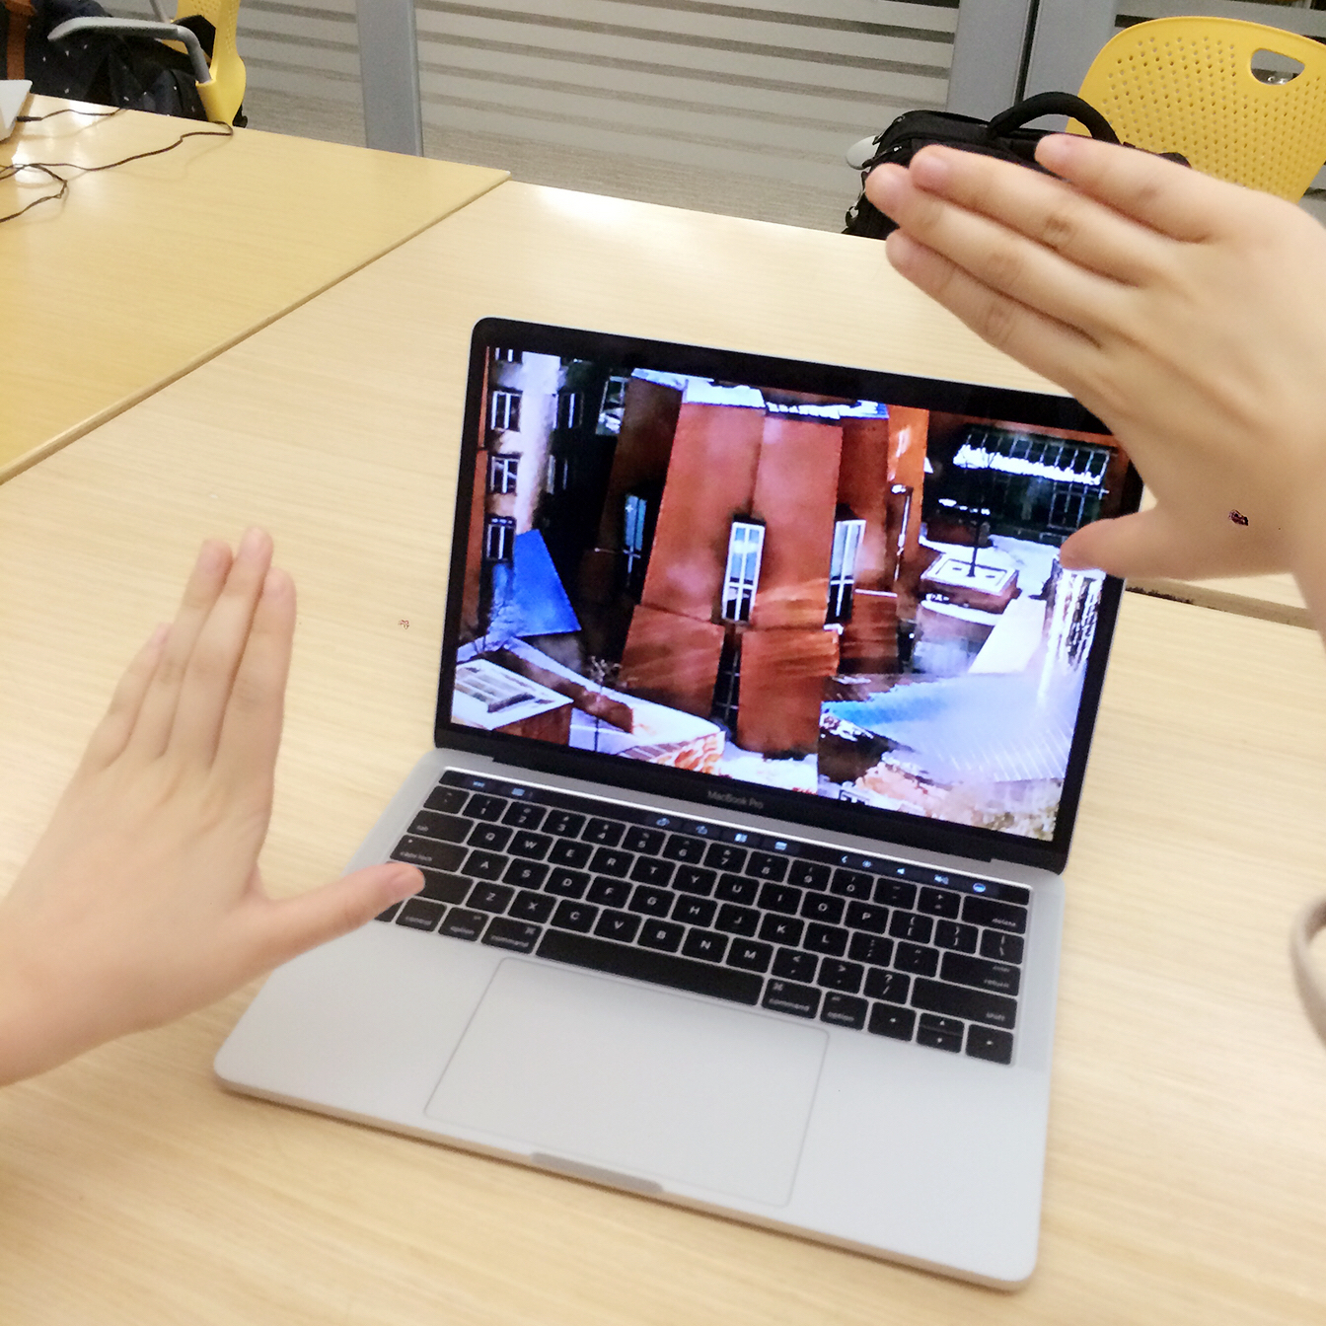

**4.5 Scenario 5 Driving**

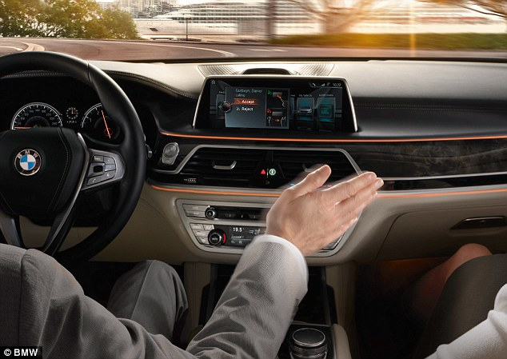

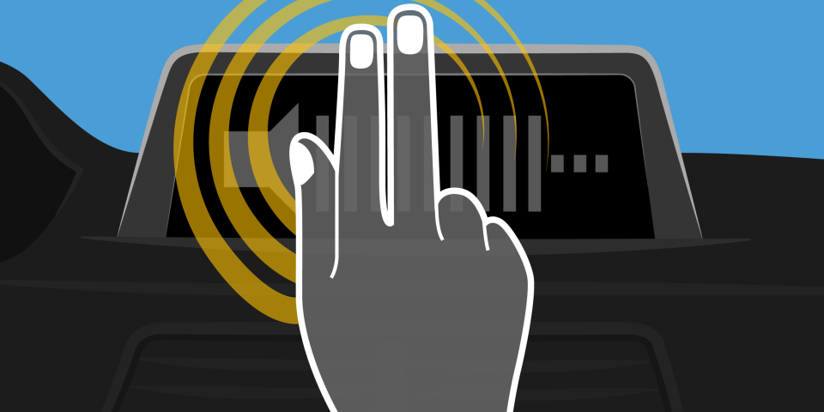

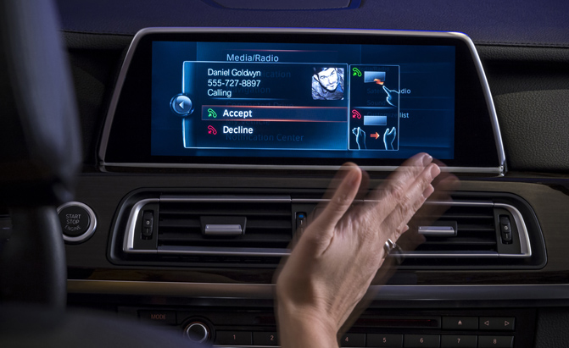

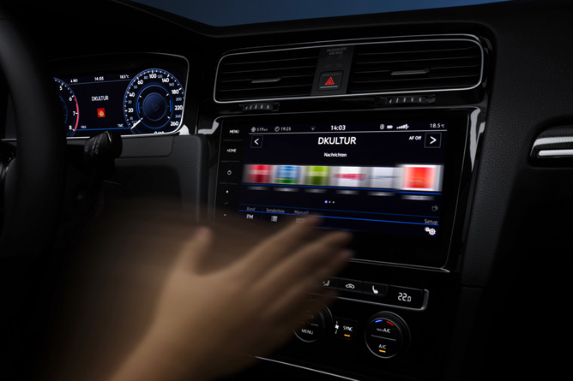

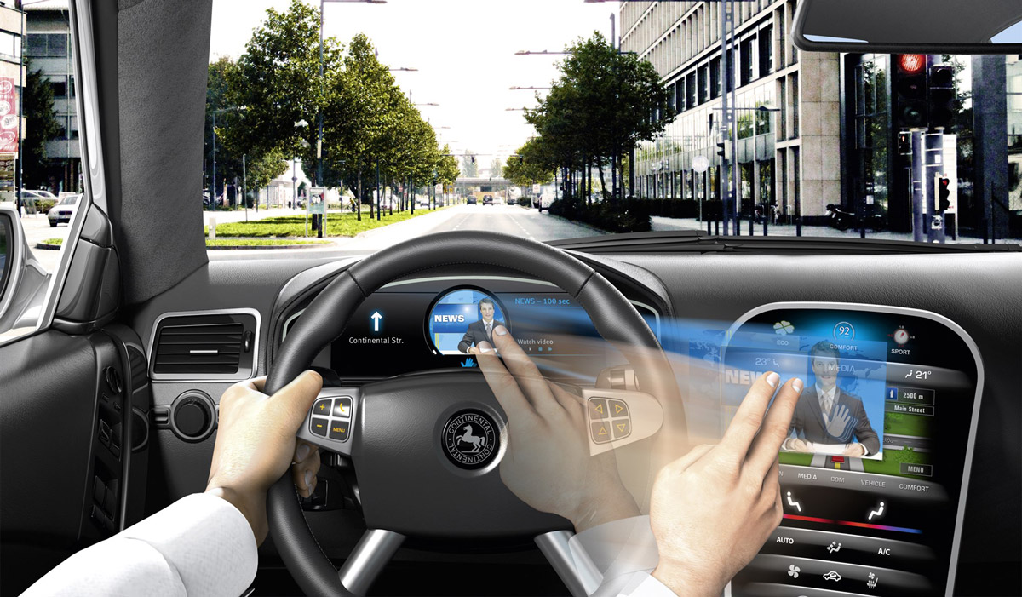

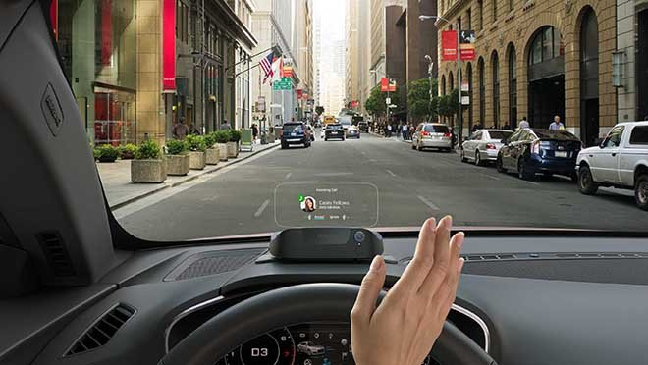

**4.6 Scenario 6 Reading machine in HKU**

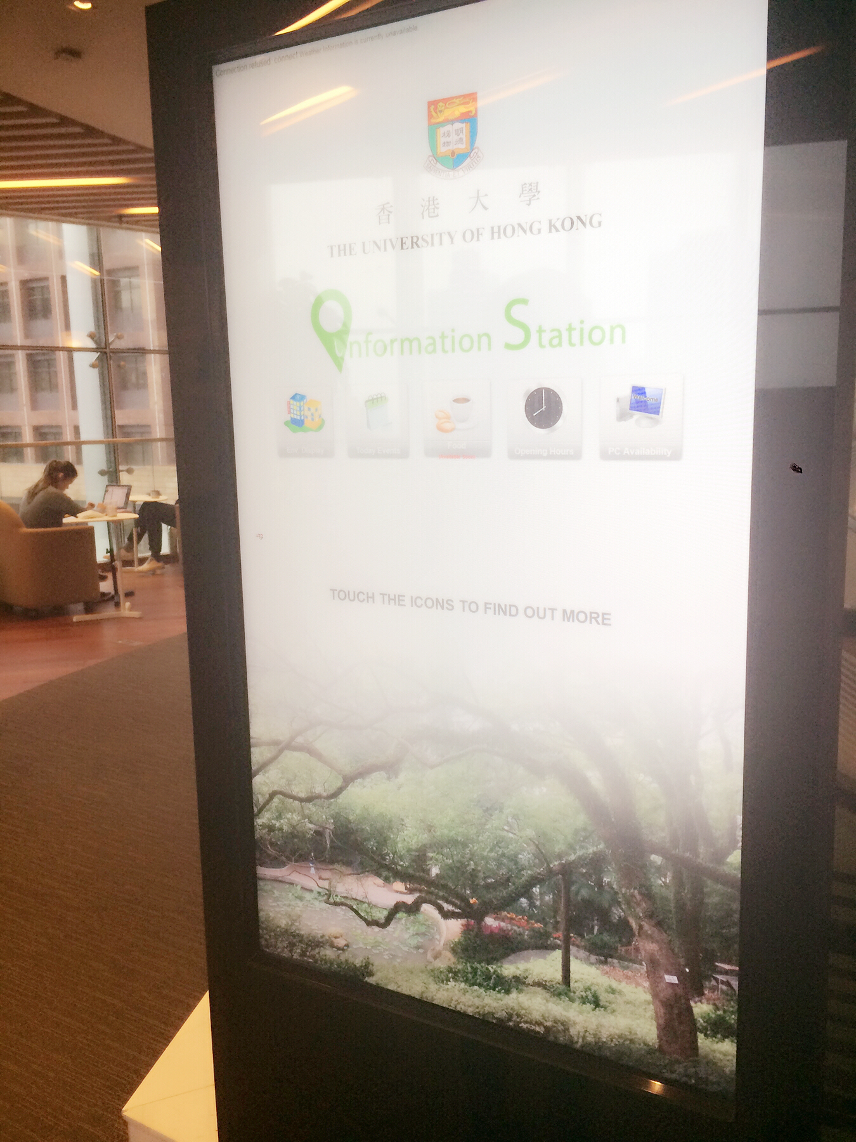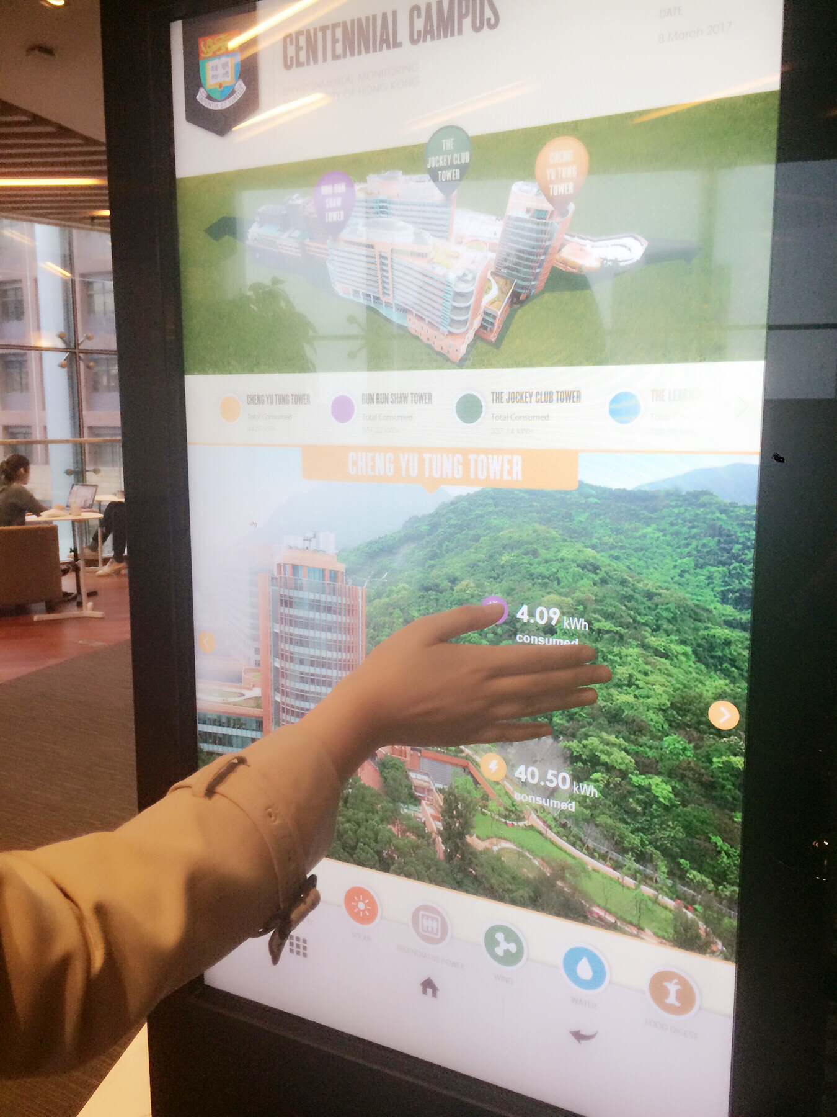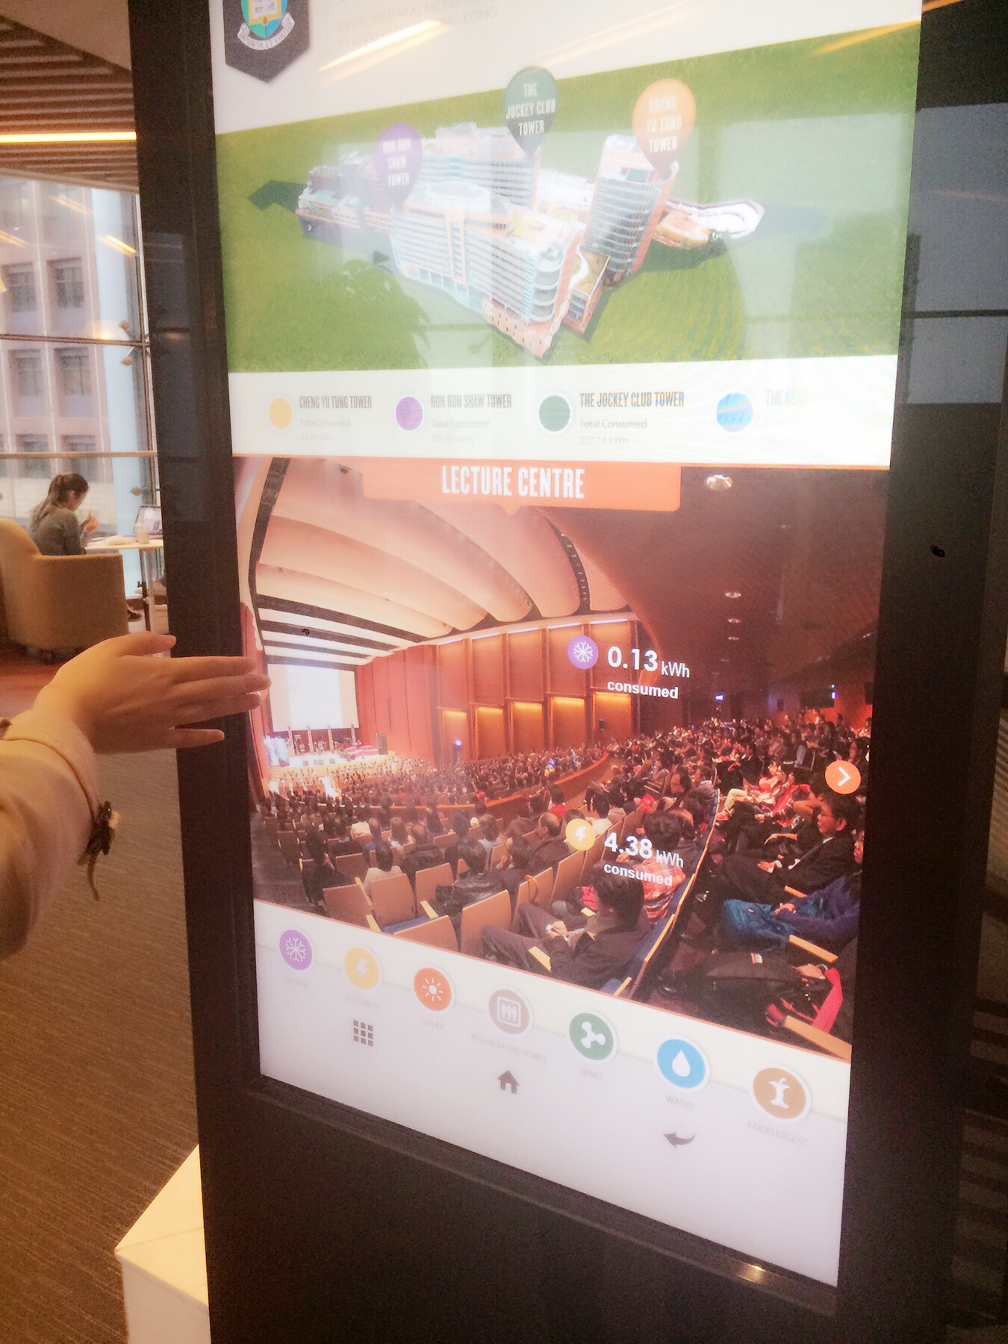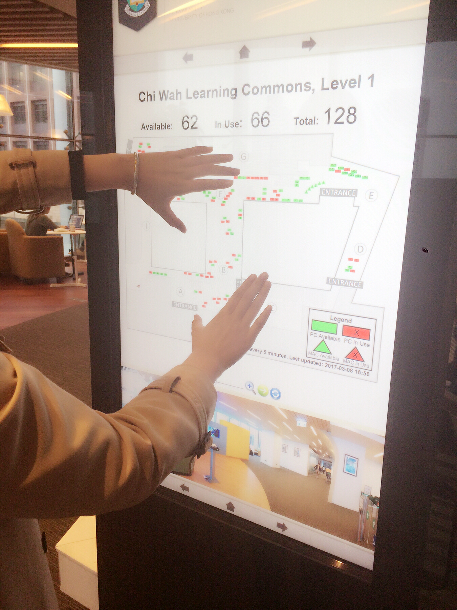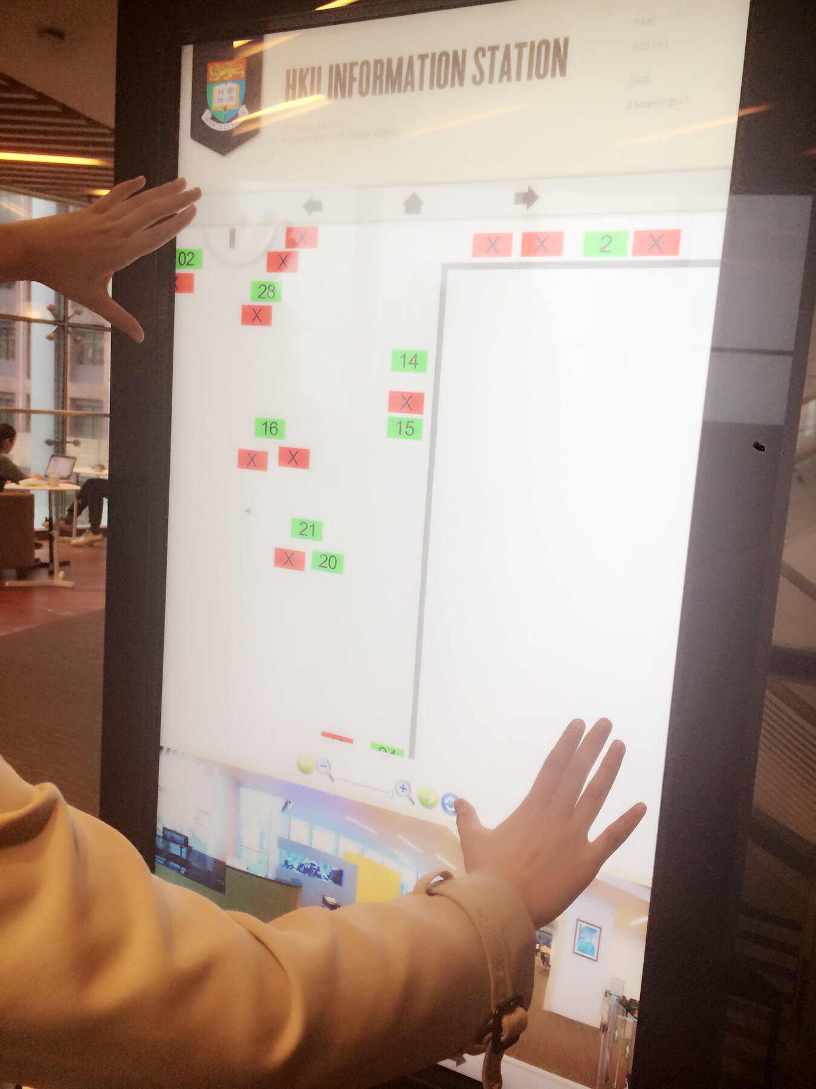

**4.7 Scenario 7 Self-timer**

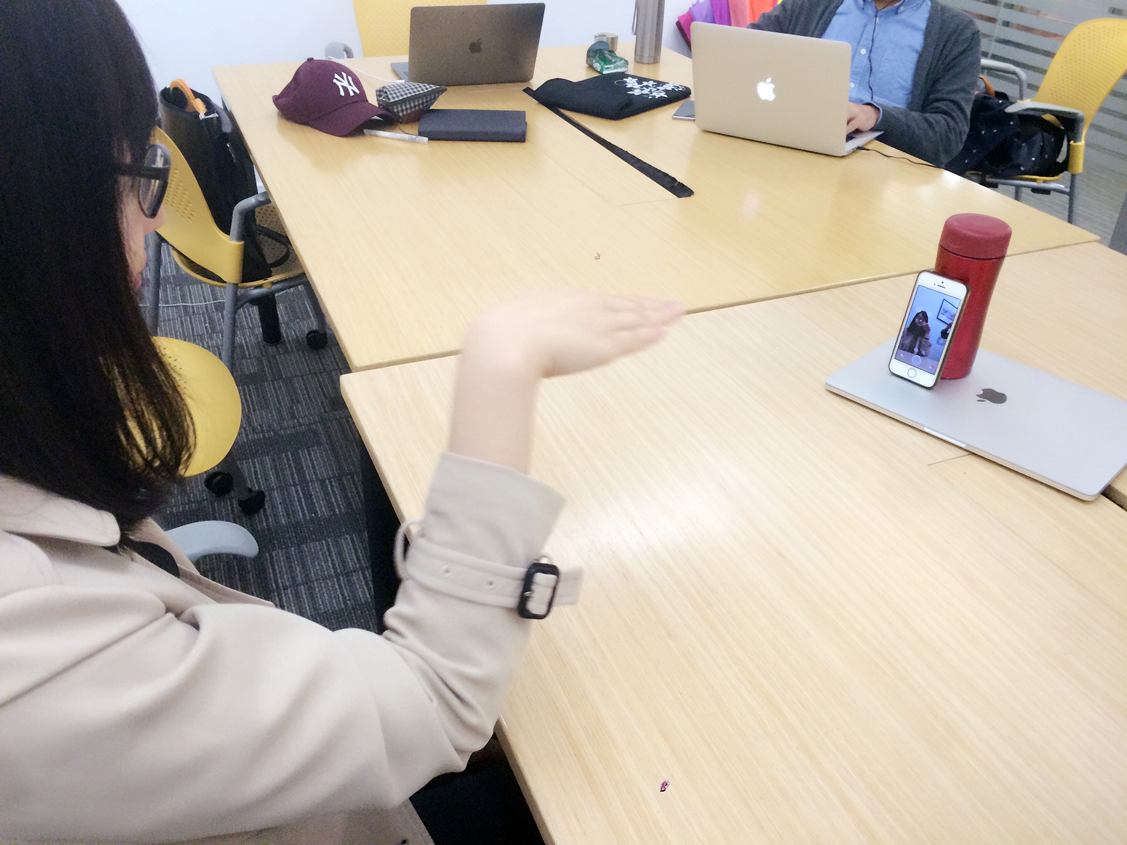

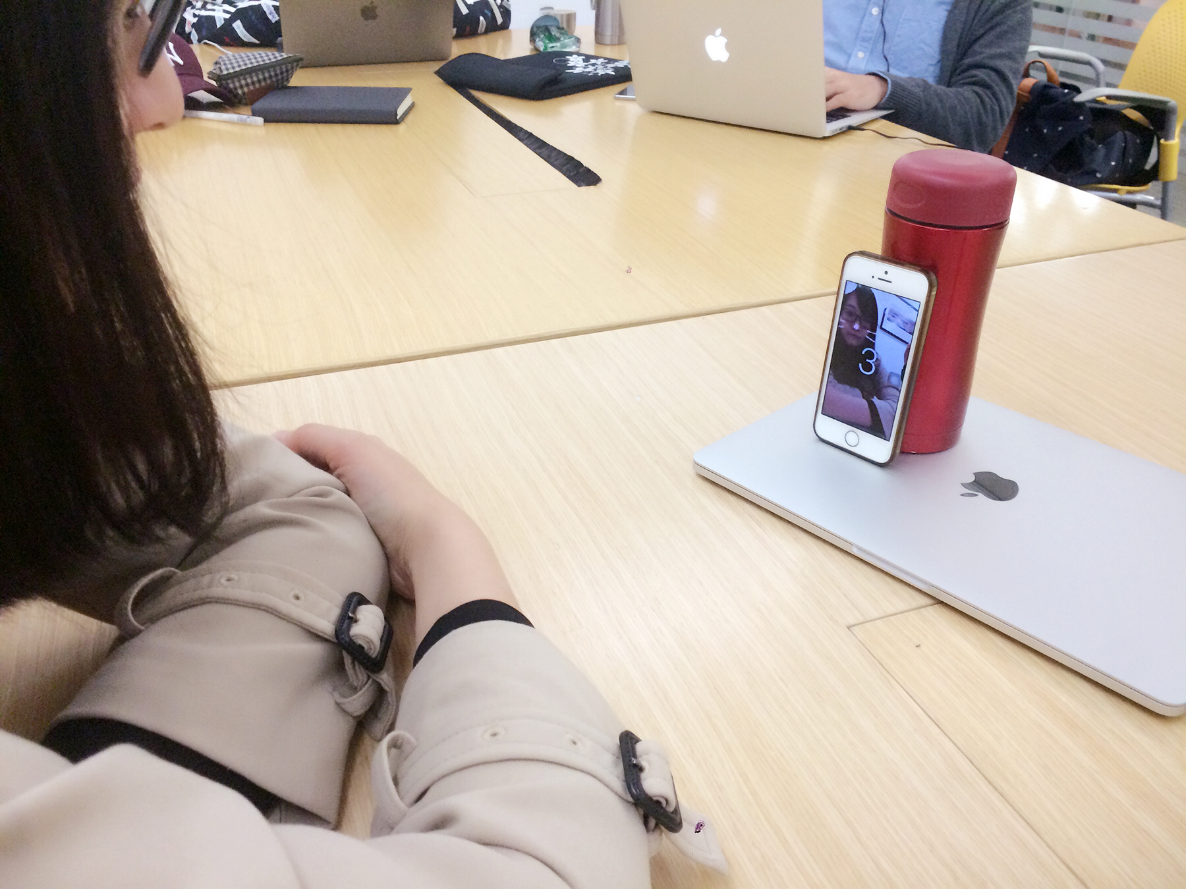

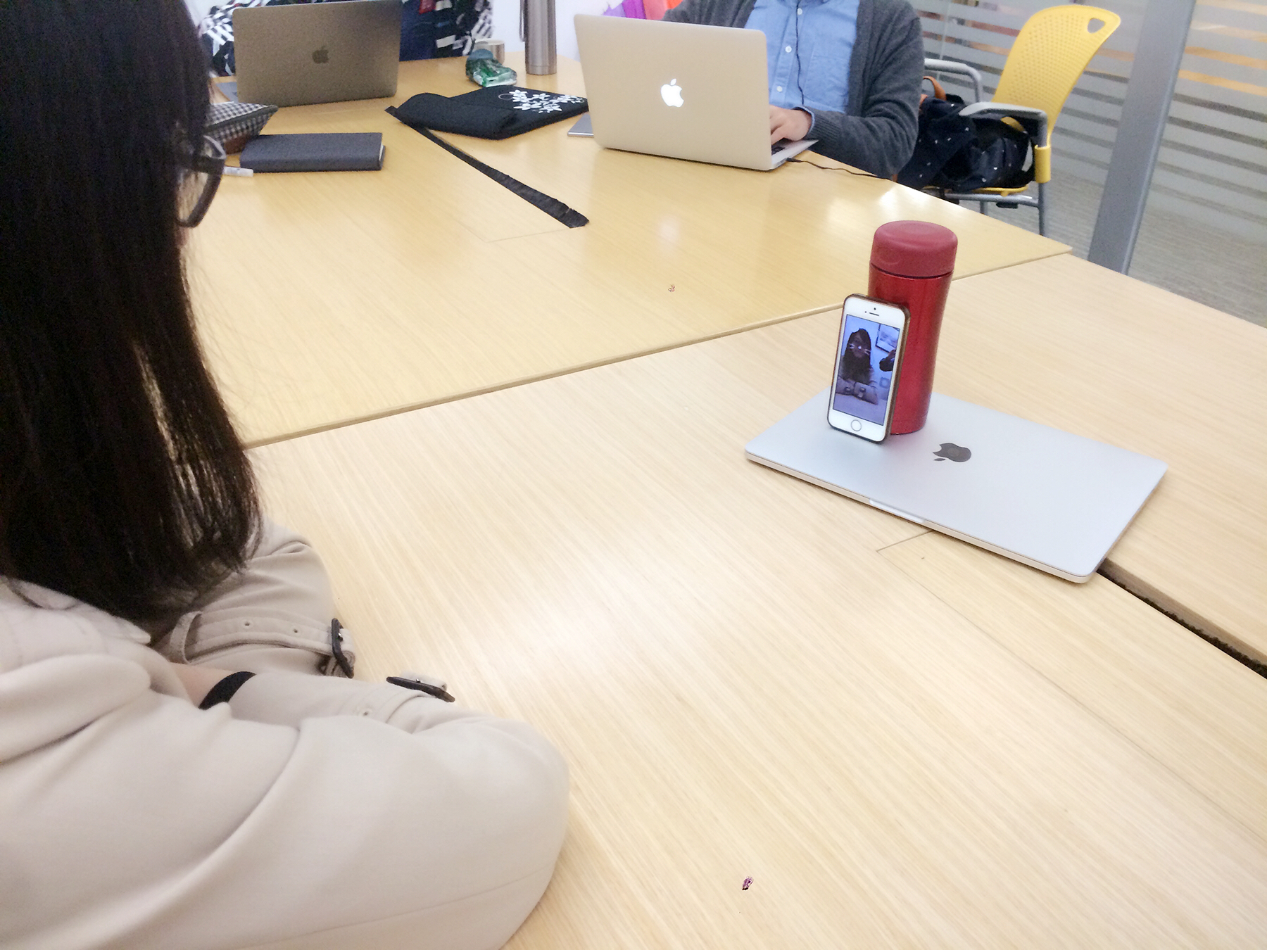

**5. 5. USABILITY TEST**

**5.1 Usability Test Procedure**

The usability test session will be one hour. The usability test procedure contains the following parts including welcome and introduction session, pre-test questionnaire, carry out the usability test tasks and the post-test questionnaire.

**5.2 Roles and Responsibilities**

During carry out the usability test tasks, all of the team members have participated in difference roles. The roles in the usability test and their responsibilities shown as the follows.

**5.3 Usability Goals**

The usability test plan is designed to evaluate the following parts.

1. Effectiveness

Identify the completion success rate on task for the test participants who have successfully completed the usability tasks without any criteria errors. The criteria errors referred to an informant and incorrect outcomes that caused the test participants cannot complete the task. A one hundred percentage of completion success rate is the goal of effectiveness in the usability test.

2. Efficiency

Identify the completed time on task measured from the test participants begin to start the usability task until the time they have completed. A shorter completed time is the goal of efficiency in the usability test.

3. Error Tolerant

Identify the error tolerant rate on task for the test participants who have successfully completed the usability tasks without any criteria or non-criteria errors. An eighty percentage of error tolerant rate is the goal of error tolerant in the usability test.

4. User Satisfaction

Identify the usefulness of the functionalities, ease of use and learning and user interface satisfaction on the overall system depends on the results from the post-test questionnaire, user’s comments and suggestions.

**5.4 User Profiles**

**5.5 Pre-testQuestionnaire**

Pre-test questionnaire have been distributed for our participants in order to identify the key expectations and the general level of user experiences. The pre-test questionnaire contains 23 statements and questions. Those statements are referring to the personal background, user experience of application and related technologies and user experience of HKU services.

**5.6 Post-activity Questionnaire**

**5.7 Questionnaire Response**

The questionnaires have been distributed to the participants of usability test group and some external participants. In total, we received 16 questionnaires across three usability test group and external participants.

7 respondents have experience in using other smart glass such as google glass. 6 respondents have experience in using some application which related to augmented reality. 7 respondents have experience in using gesture control. 14 respondents have voice control for application experience. All of the respondents have use the services in the HKU previously.

**5.8 Analysis of Questions**

*5.8.1 Analysis of Usefulness of Functionalities*

100% respondents agreed that using the smart glass allows them to achieve and accomplish the job more quickly. No comments were received in relation to this question.

*5.8.2 Analysis of ease of uses and learning questions*

*5.8.3 Analysis of User Interface Satisfaction*

**6. EVALUATION AND FINDINGS**

**6.1 Error Tolerant Rate on Task**

**6.2 Task Completion Rate**

**6.3 Time on Tasks**

**6.4**

**Usefulness of the Functionalities**

**6.5 Ease of Use and Learning**

**6.6 User Interface Satisfaction**

**6.7 Recommendation and Improvement**

**7. CONCLUSION**

Currently, touchless human-machine interaction under ultrasonic wave gesture recognition is a more natural and practical choice compared with other existing ways. In the near future, touchless interaction will be highly demanded by people and it is very likely that ultrasonic wave will play the role even though there are still challenges and limitations exist. At the same time, it will be a large revolution to change totally from traditional touch or click interaction to un-contact interaction which will greatly change people’s life style, also there is still a long way for us to explore to implement that achievement. In this project, we have exhibit our imagination to explore more possibility and people’s potential expection based on the current technology, however absolutely there will be more possibilities and breakthroughs come up later which will be out of what we can imagine. We believe the current limitations will not be a problem in the near future and this technology will bring us more surprise to help improve our life and human and machine will communicate in a more natural and efficient way which will be really exciting. Finally, this project have include almost all the cases about ultrasonic wave gesture recognition technology and provide some extra ideas which are expected to be applied in the future.

**8. REFERENCES**

[1] Yang Qifan, Tang Hao, Zhao Xuebing, Li Yin, “Dolphin: Ultrasonic-based Gesture Recognition on Smartphone Platform.”2014 17th IEEE International Conference on Computational Science and Technology, 2014

[2] Chunyi Peng, Guobin Shen, Yongguang Zhang, Yanlin Li, Kun Tan, “BeepBeep: A High Accuracy Acoustic Ranging System using COTS Mobile Devices.” [International Conference on Embedded Networked Sensor Systems](http://www.baidu.com/link?url=WsMcr9D3B1D7XA5MaUlQjaAfX4c4b6IYazdHMUOAVQu4Mjq4AZnJ5F1UYb1zGBu7ZTjOwgS5V9wRbZCjwy6W_GokP0DojiUBnj7Ci2-0R1nnwBYO79ln0b_nJLiqFoZ94_mkz-CTyx0Yhbvjdl_FIaq4bVkWLKMHYOxcETStwRIg6VarQDcTqmJt6d7YbtAEvgNs9fNB-2RP9QDMdvYNc5Ilyn2cEAqP6xquVaaUeanD50N8naIicSTSHqnxvclJQzHM-BRLOCGX4n-5tNYhCXw2nfMeVlpazGphDl4PbiK)， 2007

[3] Kalgaonkar, K. and Raj, B. “One-handed gesture recognition using ultrasonic Doppler sonar,” In Proc. Of IEEE Acoustics, Speech and Signal Processing 2009.

[4] Stephen P. Tarzia, Robert P. Dick, Peter A. Dinda, Gokhan Memik, “Sonar-based measurement of user presence and attention.” In Proc. ACM UbiComp 2009.

[5] Junjue Wang, Kaichen Zhao, Xinyu Zhang, “Ubiquitous Keyboard for Small Mobile Devices: Harnessin Multipath Fading for Fine-Grained Keystroke Localization.”, International Conference on Mobile Systems, 2014

[6] [Przybyla, R.J](http://www.baidu.com/link?url=LKMKUN50-PWhVVi1J34BVYyvM6yHXQhpgrKHwRlgWV68oQAMeeGSZQYX5ZEuE5LY4dFicFx3xwVn3XSNVf7HklLamJxj6IdG1AIKkhDlO-2CsAwanZiPneAk9Bt9O_wLa6FJJYY2NzX9HCzh-8vtz1kwQnSGWMKBcAbdBmyeKfQQoSueIYeFq-oa1Jaeqdcp) , [Hao-Yen Tang](http://www.baidu.com/link?url=_fCTd-dFFwO68eXHfNnWufuSgqco_T4OKXvUDUVrRQy3zgZwt8cQTXOxz3N9eSq2sojV_ZcV4Hr5awWc_Q403i30Wnp9VN5BdjTA3PuJpk-EGFJTK7FaiVcnCZi95Ow9z6dhjyoWyl9gn0T6lqMtiI6heQLWw1uJ_h_yMpgaS3zp1-QnS7YU7lHXAumJZ3QE) , [Shelton, S.E](http://www.baidu.com/link?url=NAxm04R5FvA7FAiSbaLoMOBgRHmTG67Wi6gf0kCeiktMnBMbApd-5PLauSuwNeTp6_qRxtaH04ahjBif_G0wFsUYwejJqUQI_uy6l4HCrcQESpk9bg_zSM4AQLm_1tu-ISDPcmLKHcvhgCdlyLkCMDmROxYJmCqifd4UonGq-XHdRo2Zjg4xfiy20zAewqj_), “3D ultrasonic gesture recognition.” Solid-state Circuits Conference Digest of Technical Papers, 2014, 57:210-211

[7] Kun Jin, Arye Nehorai, “Ultrasonic Gesture Recognition with Neural Network

”, Washington University in St. Louis, Available: http://www.ese.wustl.edu/~nehorai/ugr/Report_UGR_Kun_Jin_2016.pdf

[11] SoundSense: 3D Gesture Sensing using Ultrasound on Mobile Devices Available: http://119.90.25.34/mrorz.github.io/files/soundsense.pdf

[12] Travis Deyle, Szabolcs Palinko, and Erika Shehan. Fingermic: A lightweight bio-acoustic finger gesture interface for hand-full computing.

[13] K. Kalgaonkar and B. Raj. One-handed gesture recognition using ultrasonic doppler sonar. In Acoustics, Speech and Signal Processing, 2009. ICASSP 2009.  IEEE International Conference on, pages 1889{1892, April 2009.

[14] Sidhant Gupta, Daniel Morris, Shwetak Patel, and Desney Tan. Soundwave: Using the doppler effect to sense gestures. In Proceedings of the SIGCHI  Conference on Human Factors in Computing Systems, CHI '12, pages 1911{1914, New York, NY, USA, 2012. ACM.

[0] Joseph Paradiso, Craig Abler, Kai-yuh Hsiao, Matthew Reynolds, “The magic carpet: physical sensing for immersive environments.” In Extended Abstracts on Human Factors in Computing Systems, Page 277-278, 1997